Lei Li and Patrick C. Wilson

WILSON LAB@ uCHICAGO

Librator V 1.0 - User manual

Table of Contents

User interface 2

Main Tab (printable) 2

Sequence Tab (printable) 3

Alignment Tab (HTML) 4

Sequence DB Tab 5

Summary Tab 6

Summary Tab (HTML) 7

Fragment DB Tab 8

Functions: 9

Basic functions: 9

Path setting 9

Create new sequence database 9

Open existing sequence database 10

Import sequences 10

Export sequences 11

Advanced functions: 12

Edit information of sequences (on Main tab) 12

HA numbering 13

Identify mutations 13

Multiple sequence alignment 14

Generate phylogenetic tree (ML tree) 15

Mutate sequence 16

Compare sequences and generate screening mutations 17

Epitope transplant across different subtypes 18

3D visualization via PyMOL 19

Generate Gibson Clone fragments 20

Contact 22

# User interface

### Main Tab (printable)

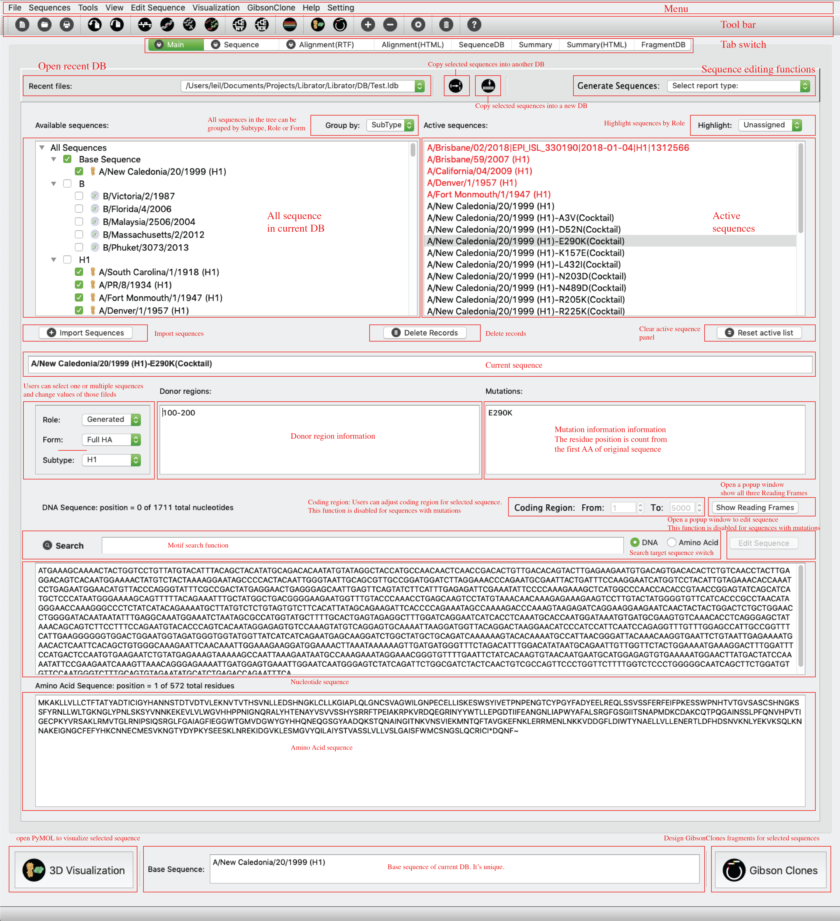

### Sequence Tab (printable)

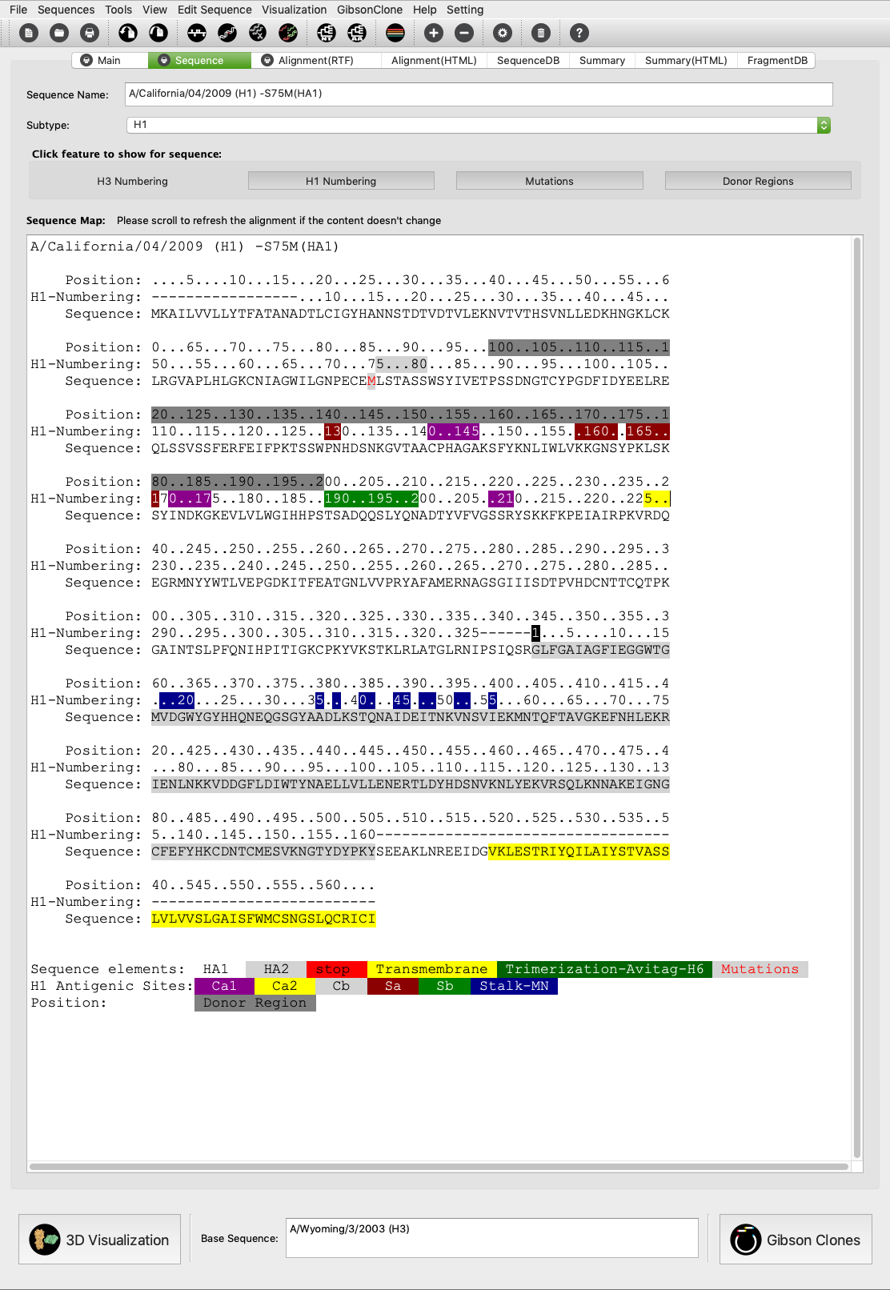

### Alignment Tab (HTML)

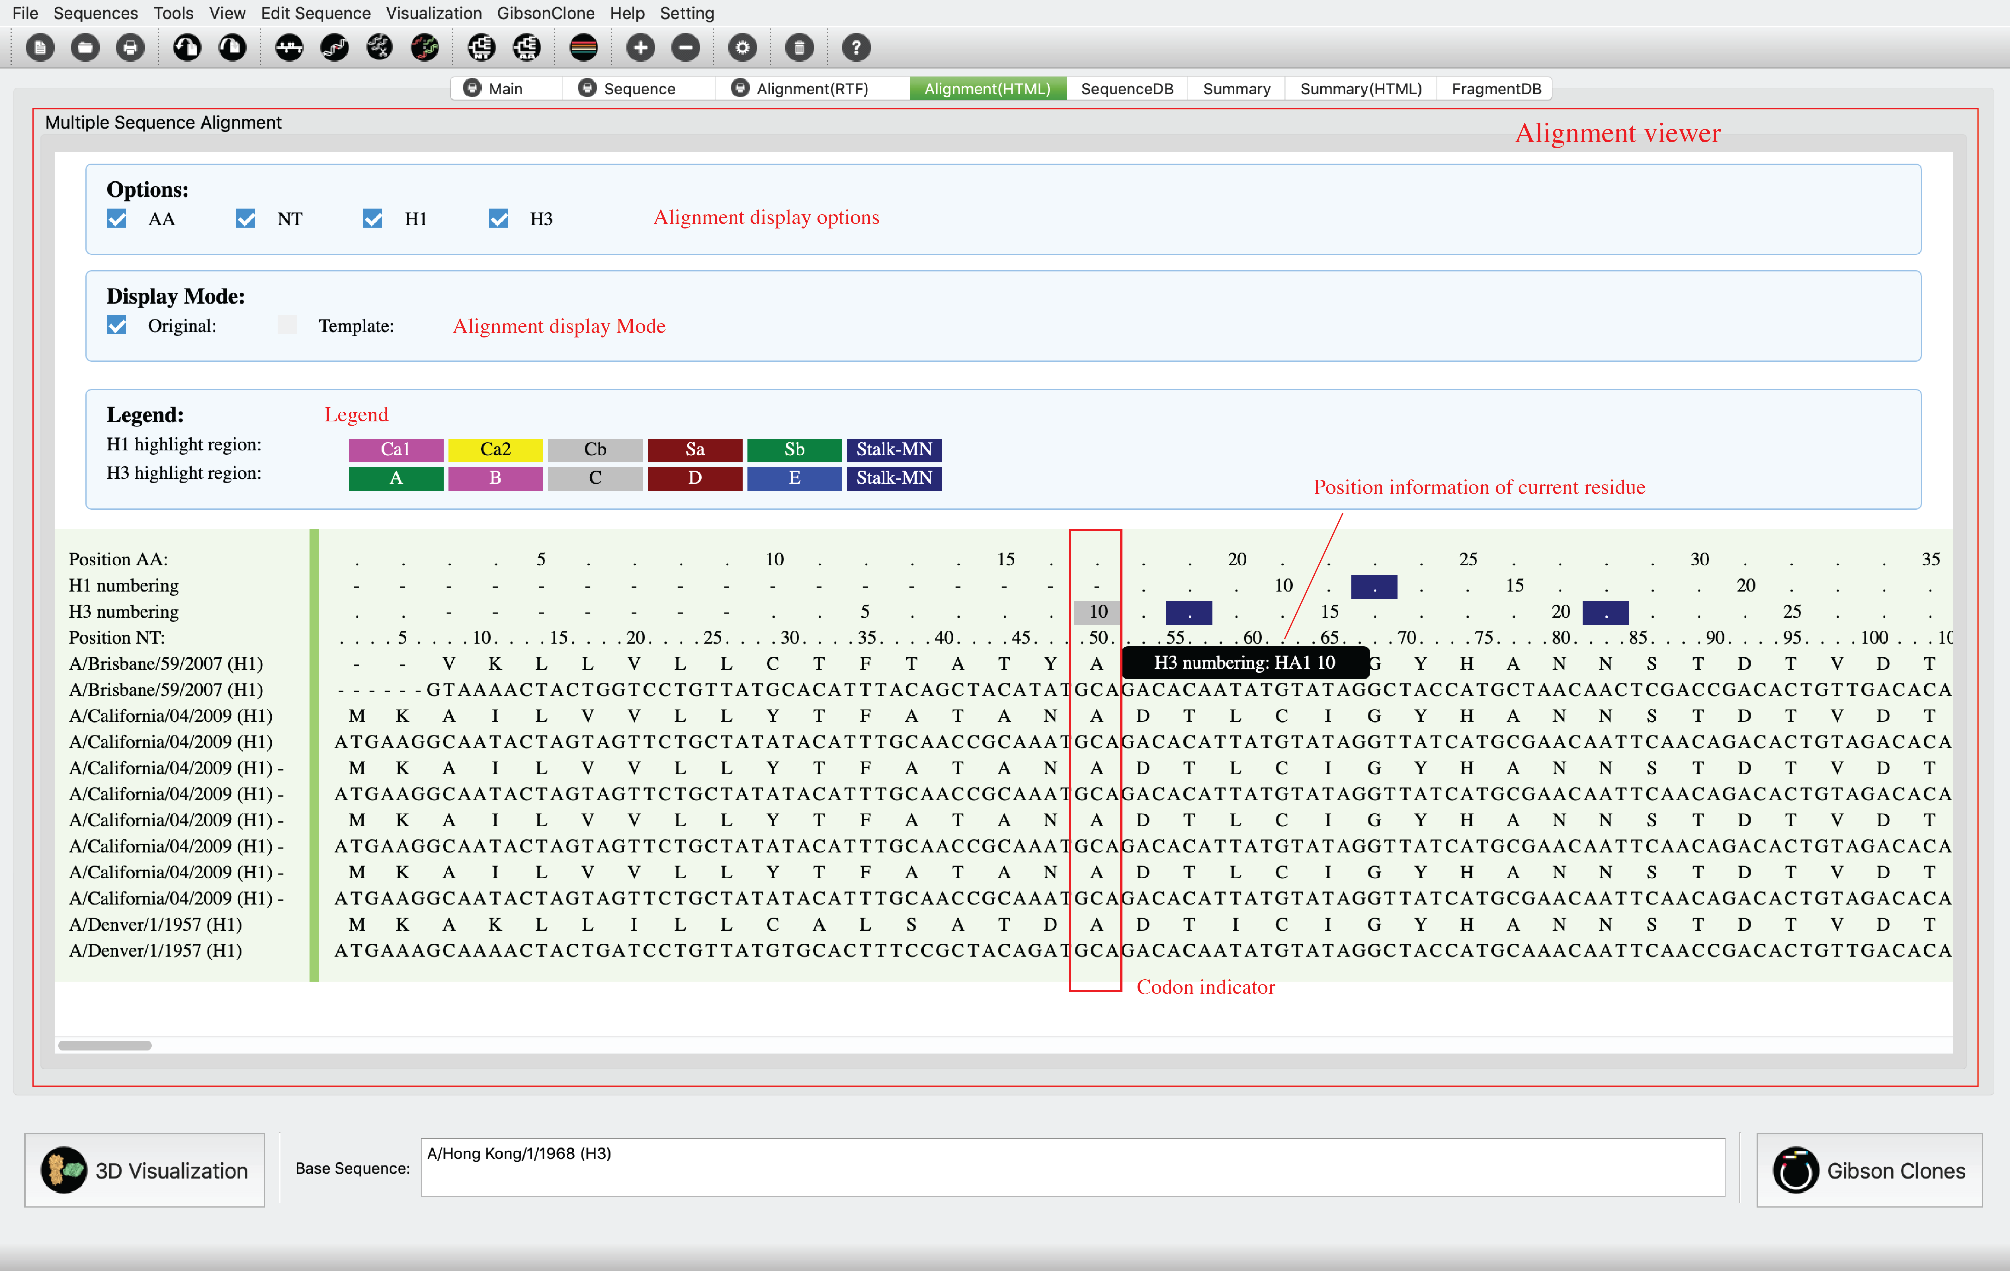

### Sequence DB Tab

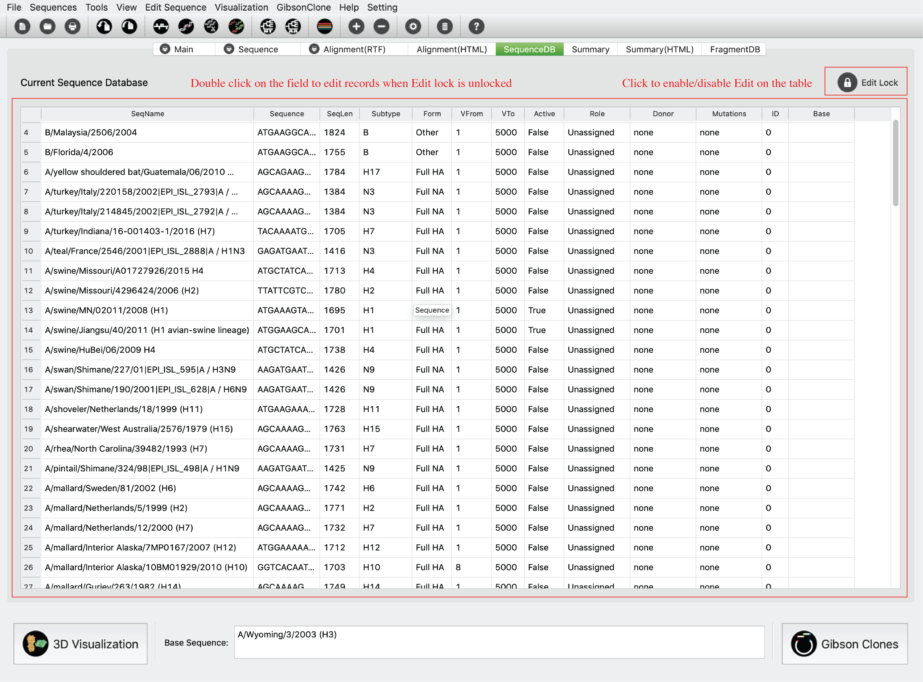

### Summary Tab

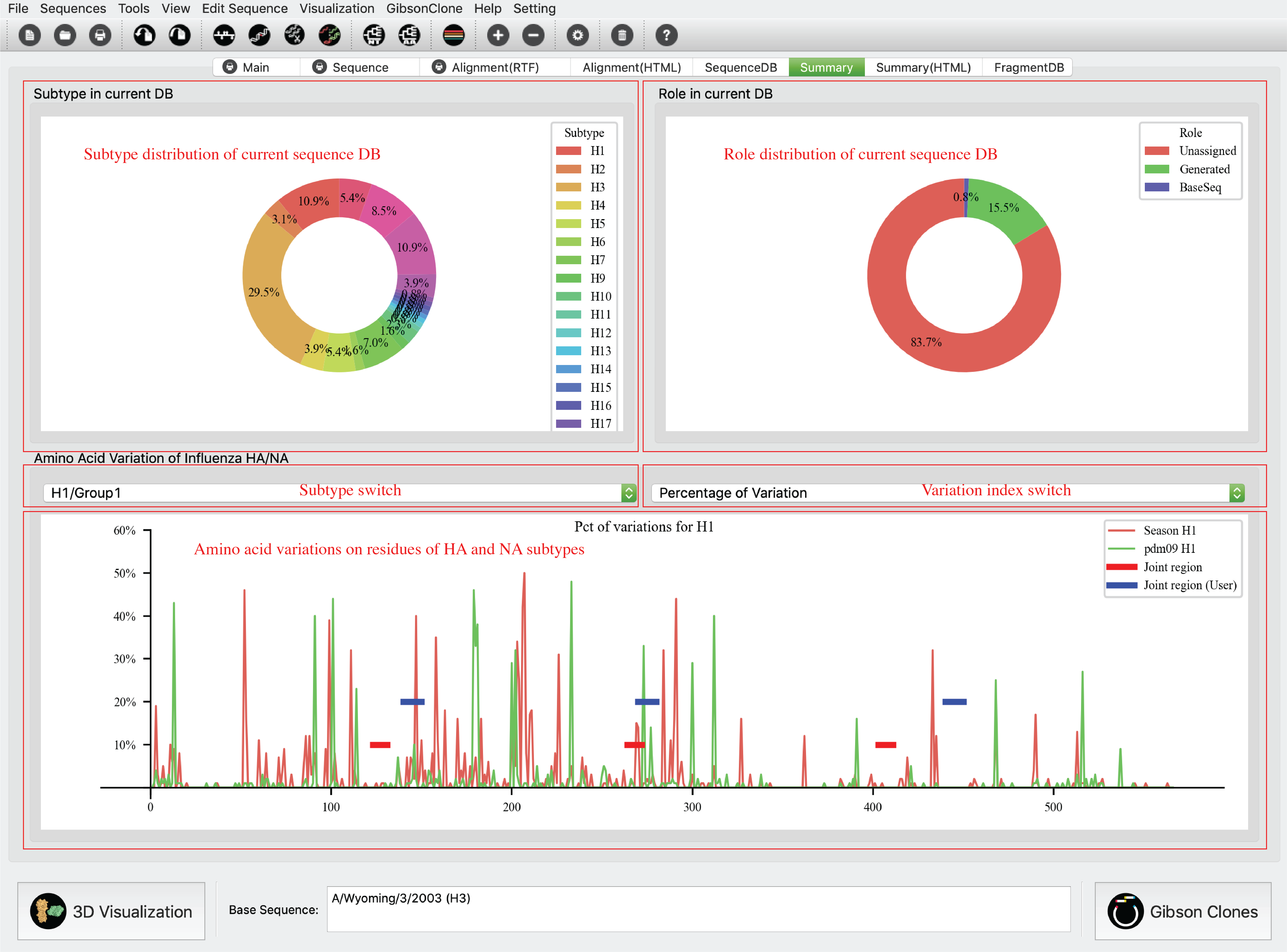

### Summary Tab (HTML)

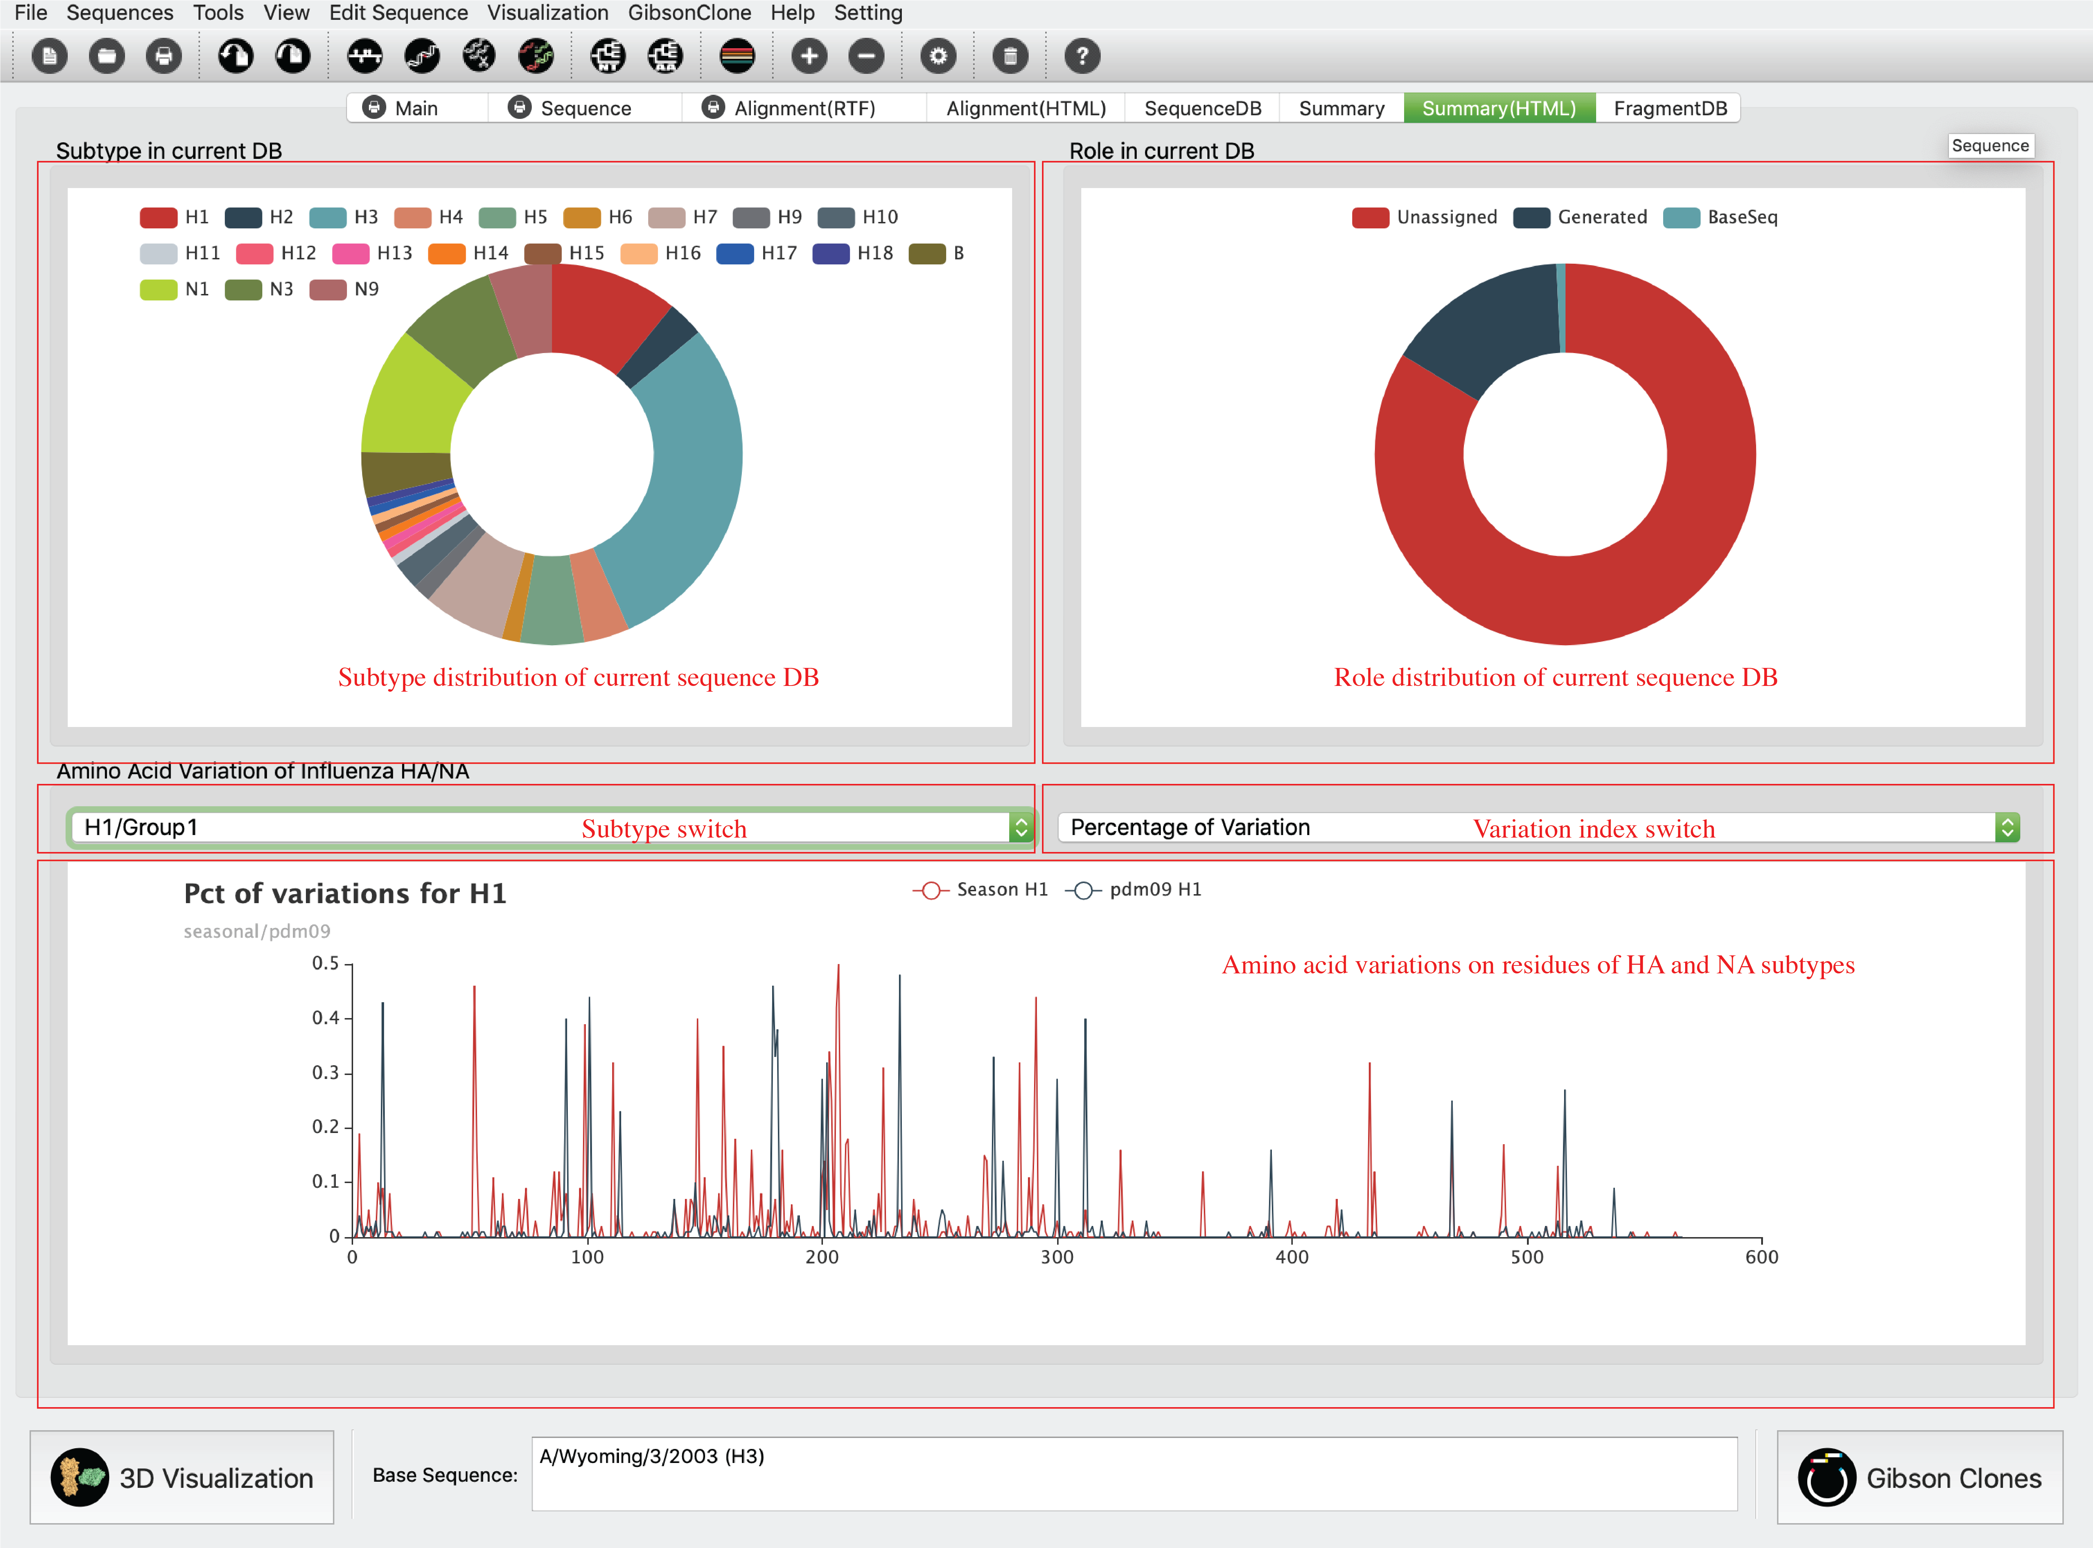

### Fragment DB Tab

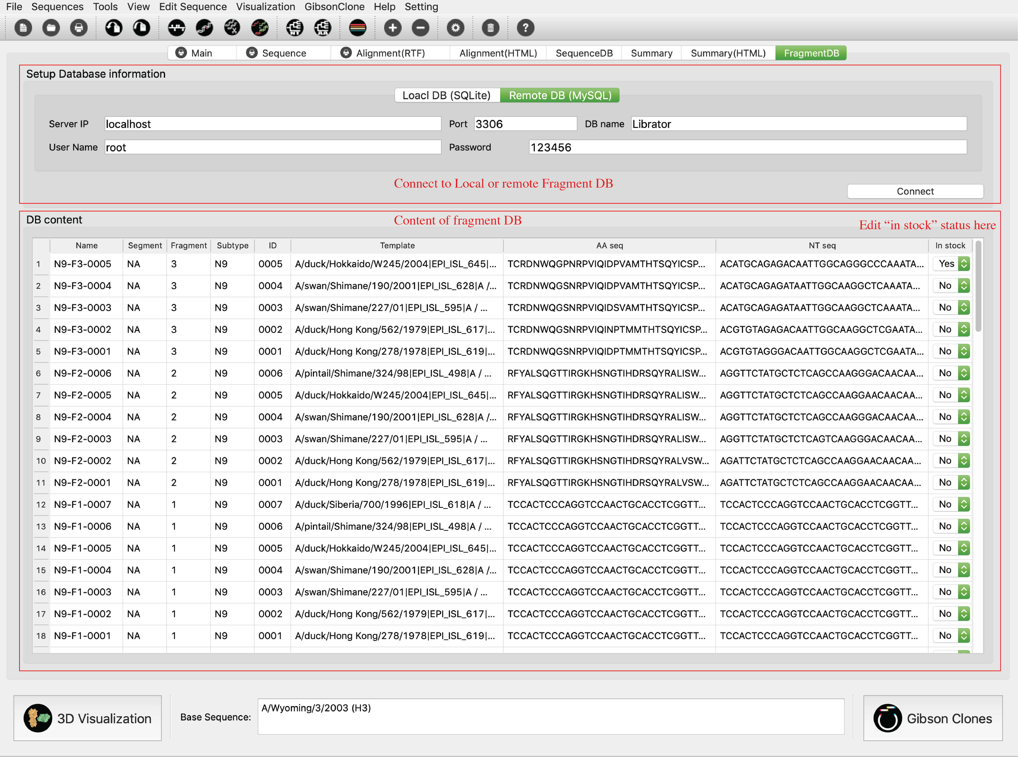

# Functions:

## Basic functions:

### Path setting

Users can set paths for all required tools and databases.

Click *Setting-> Preferences* in menu or click  in *Tool bar*.

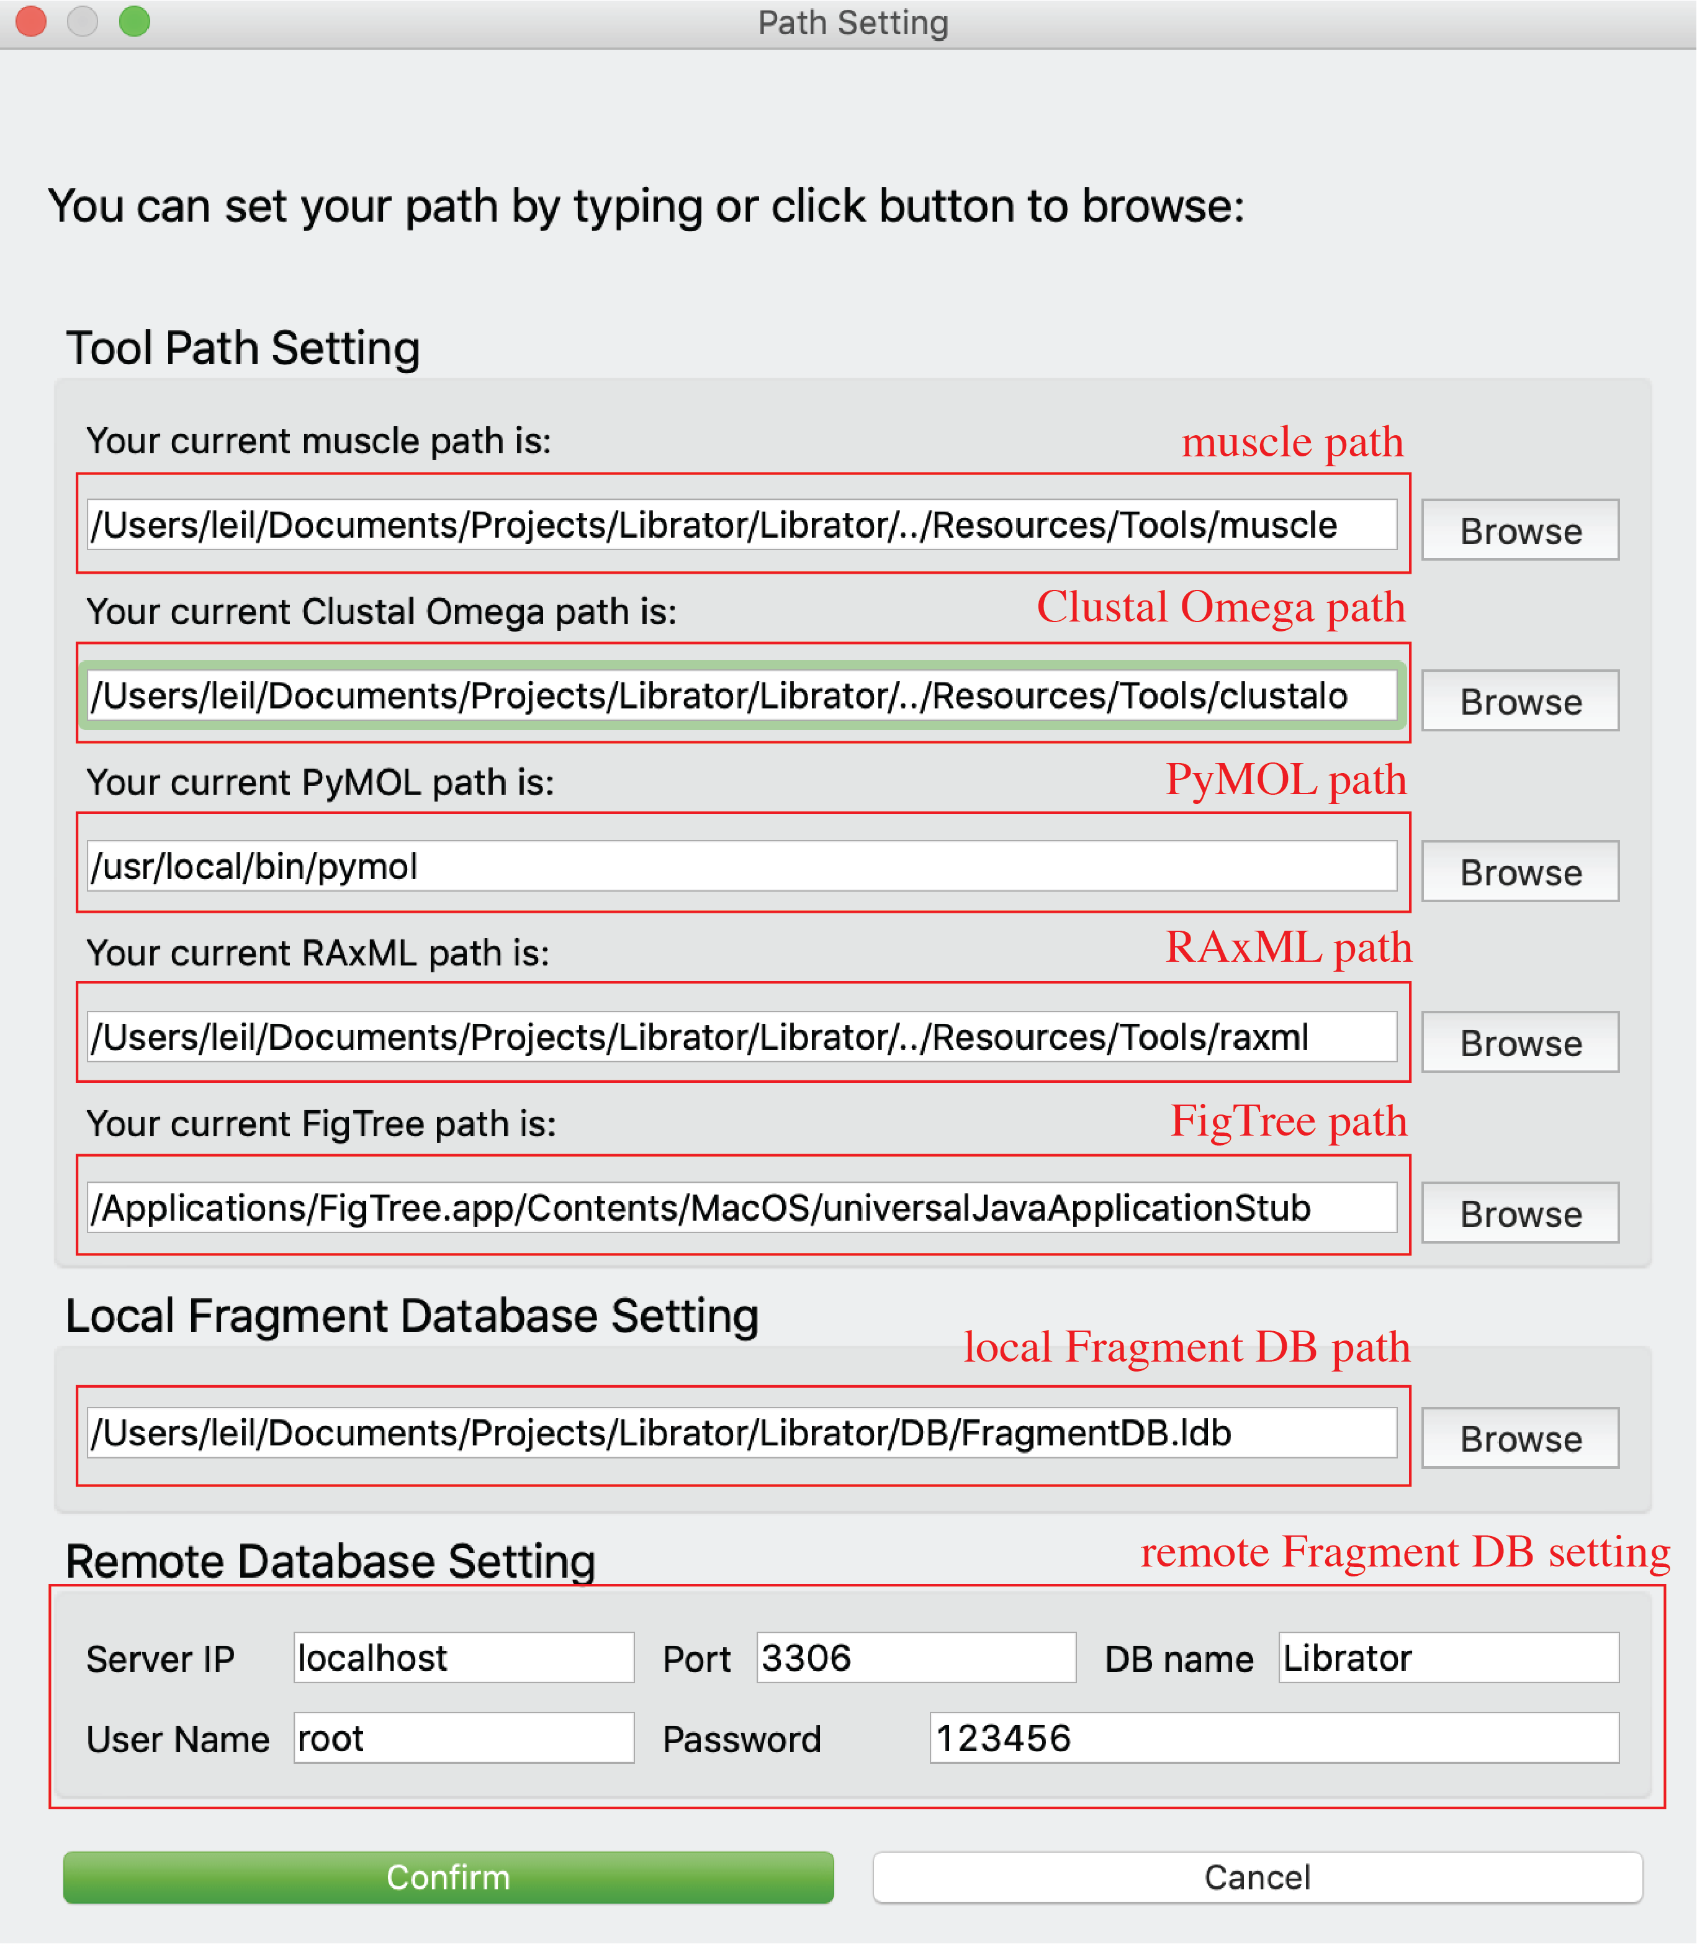

### Create new sequence database

Users can create new sequence database.

Click *File-> New* in menu or click  in *Tool bar*.

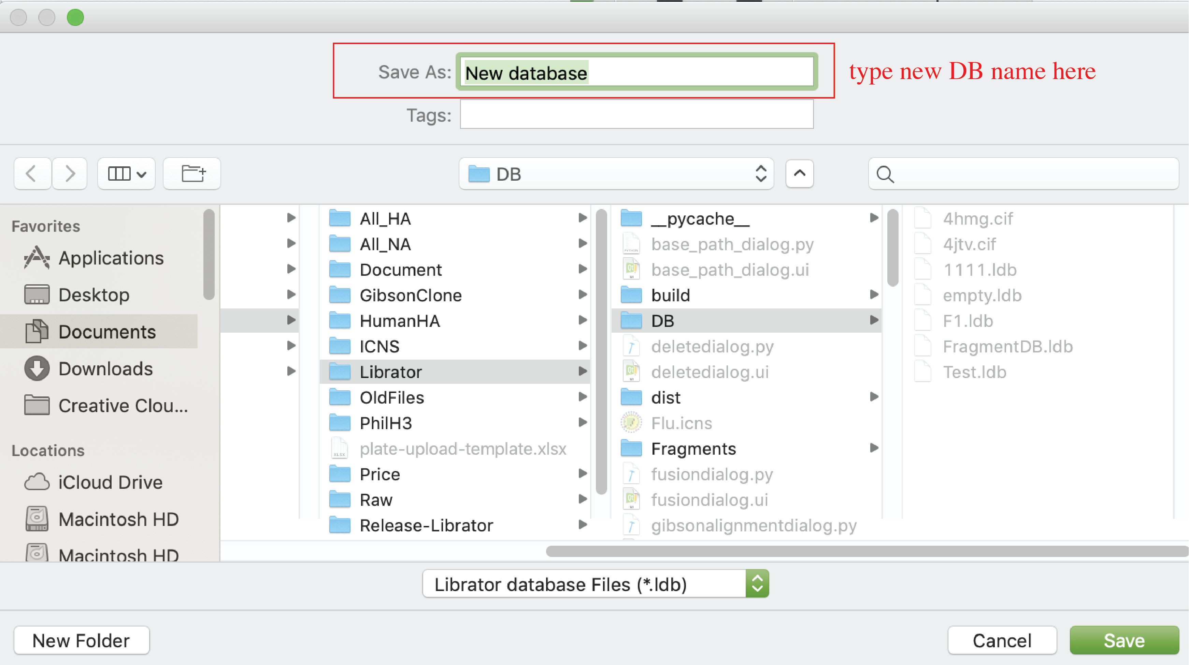

### Open existing sequence database

Users can create new sequence database.

Click *File-> Open* in menu or click  in *Tool bar*.

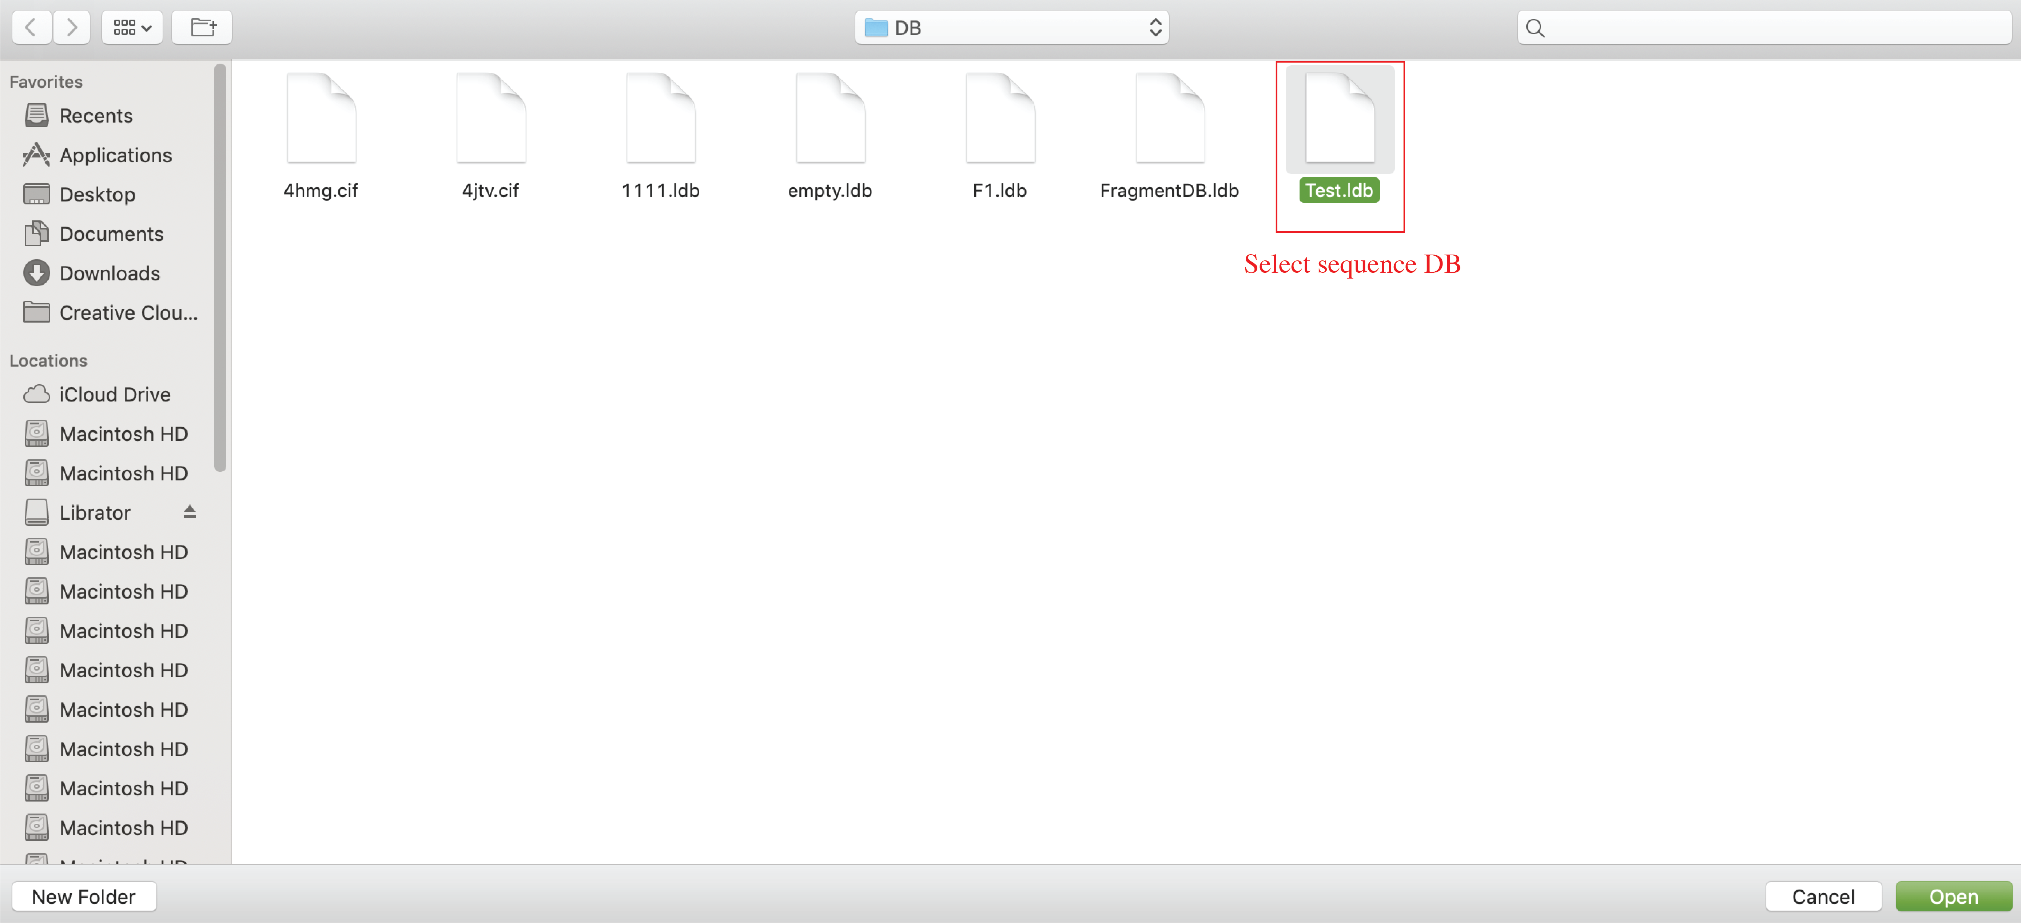

### Import sequences

After load an existing sequence database, users can import sequence into current database. The input files should be in FASTA format.

Click *Sequences-> Import* in menu or click in *Tool bar* or click “import sequences” button in Main tab.

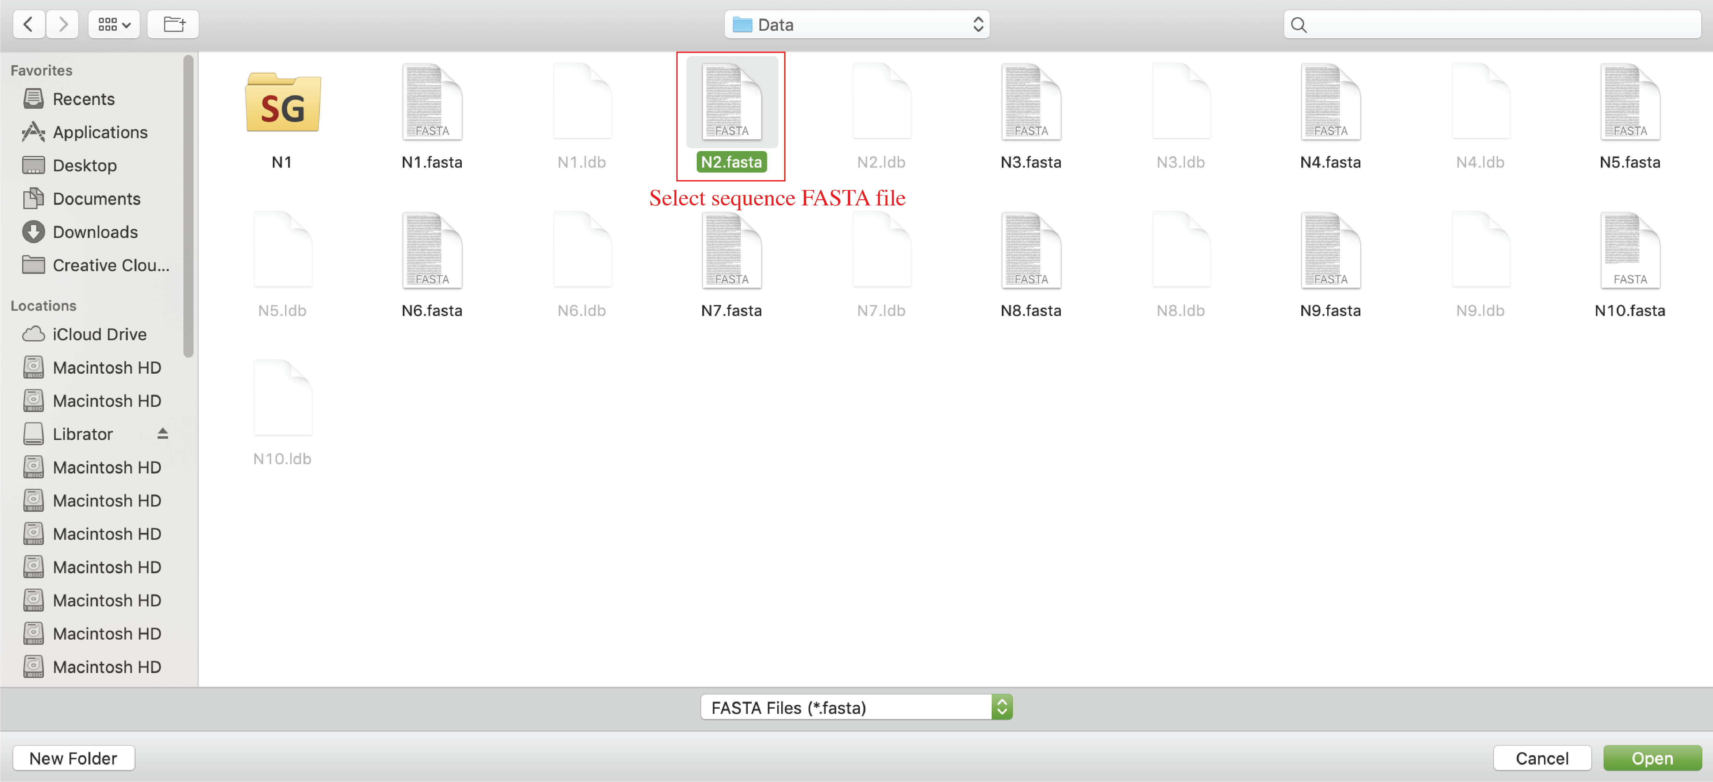

### Export sequences

After load an existing sequence database, users can import sequence into current database. Selected sequences will be exported to a FASTA file.

Click *Sequences-> Export* in menu or click  in *Tool bar*.

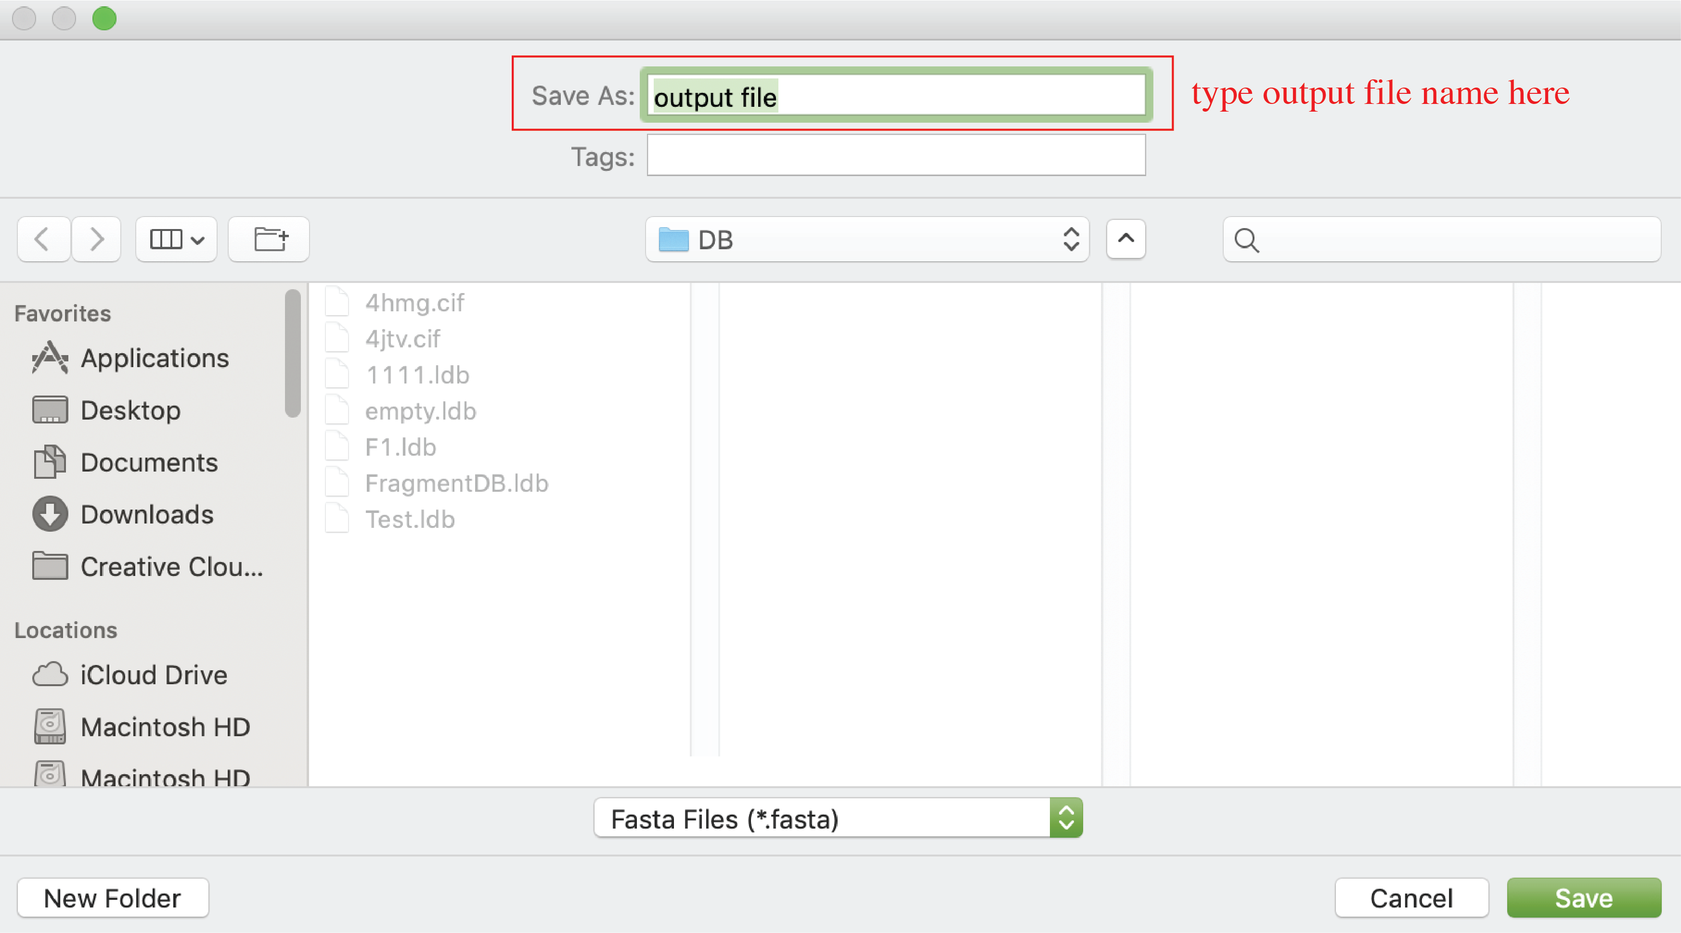

## Advanced functions:

### Edit information of sequences (on Main tab)

Users can edit information (**sequence name**, **Role**, **Form**, **Subtype**, **NT sequence**, **reading frame**, **donor regions**) of sequences on main tab.

For **Sequence name**, users can click sequence name text input to edit it.

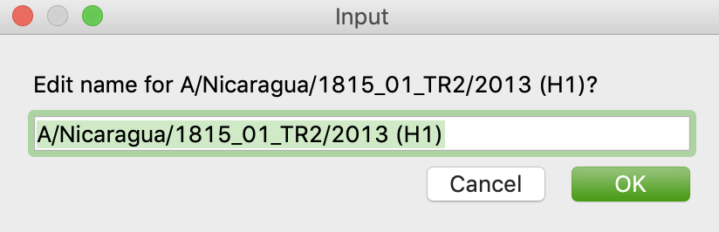

For **Role**, **Form**, and **Subtype**, users can edit by the left panel. Users can select multiple sequences in active sequence panel to do bulk update.

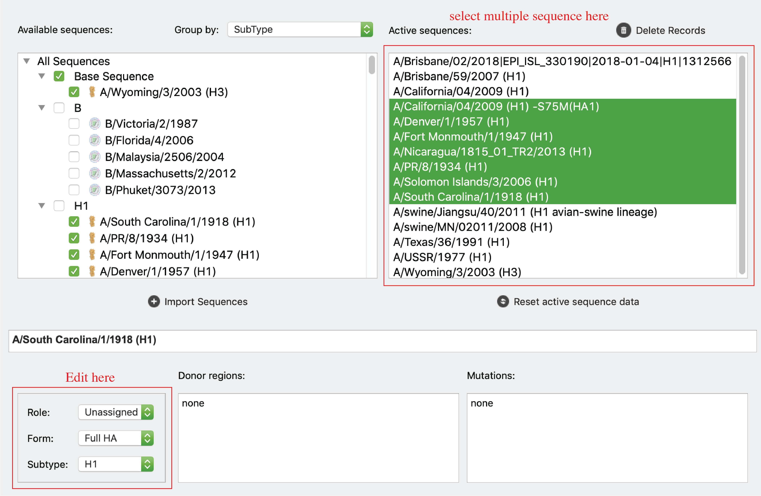

For **reading frame** start and end, users can use the “Coding region” inputs.

For **NT sequences**, users can click “edit sequence” button to edit sequences.

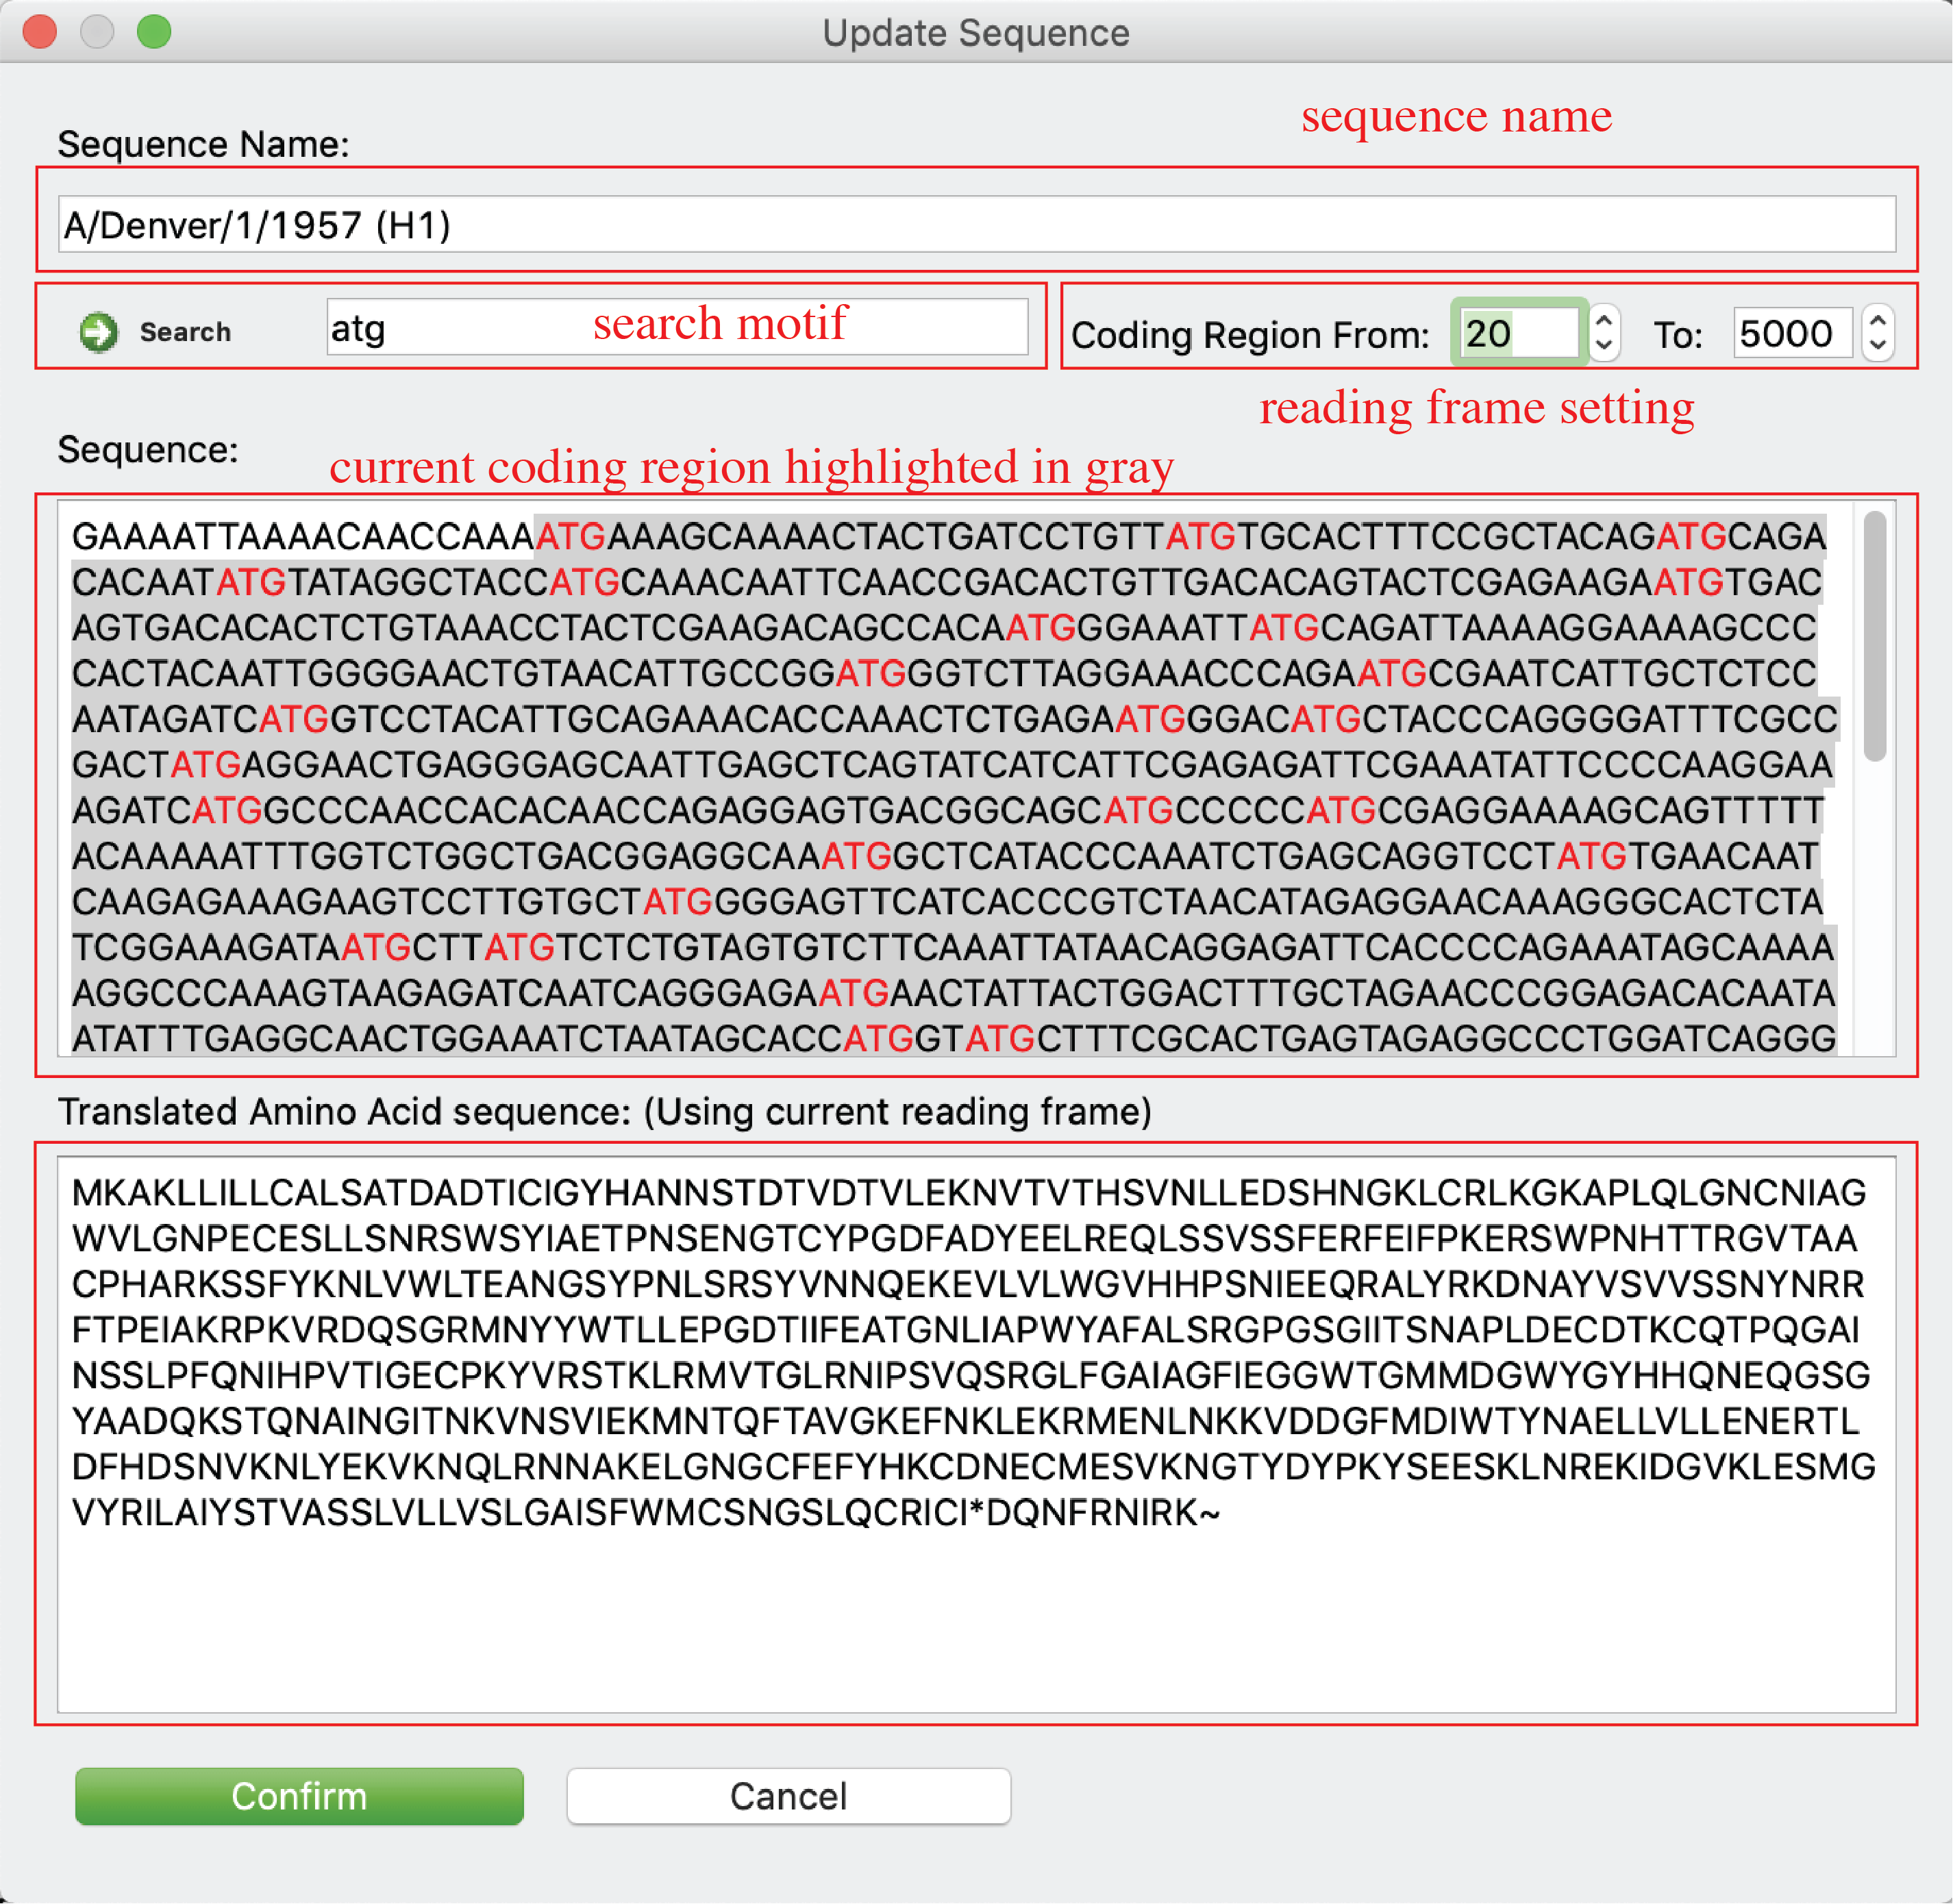

Note: coding region and NT sequence editing is disabled for sequences with mutation information.

For **donor regions** information, users can click “Donor region” input to update information.

### HA numbering

Users can access H1/H3 numbering of selected sequence.

Click *Tools-> HA Numbering* in menu or just click “Sequence” tab.

Please see “Sequence” Tab for interface and details.

### Identify mutations

Users can identify mutations between any two sequences.

Click *Tools->Identify Mutation* in menu or just click  in *Tool bar* to open the function window. Then select one sequence as template, determine the sequence that user want to identify mutation from as target sequence. Then the alignment will show in the HTML viewer and all mutations will be listed in the bottom text box. Users can save mutation/template information to the target sequence by clicking “Confirm” button.

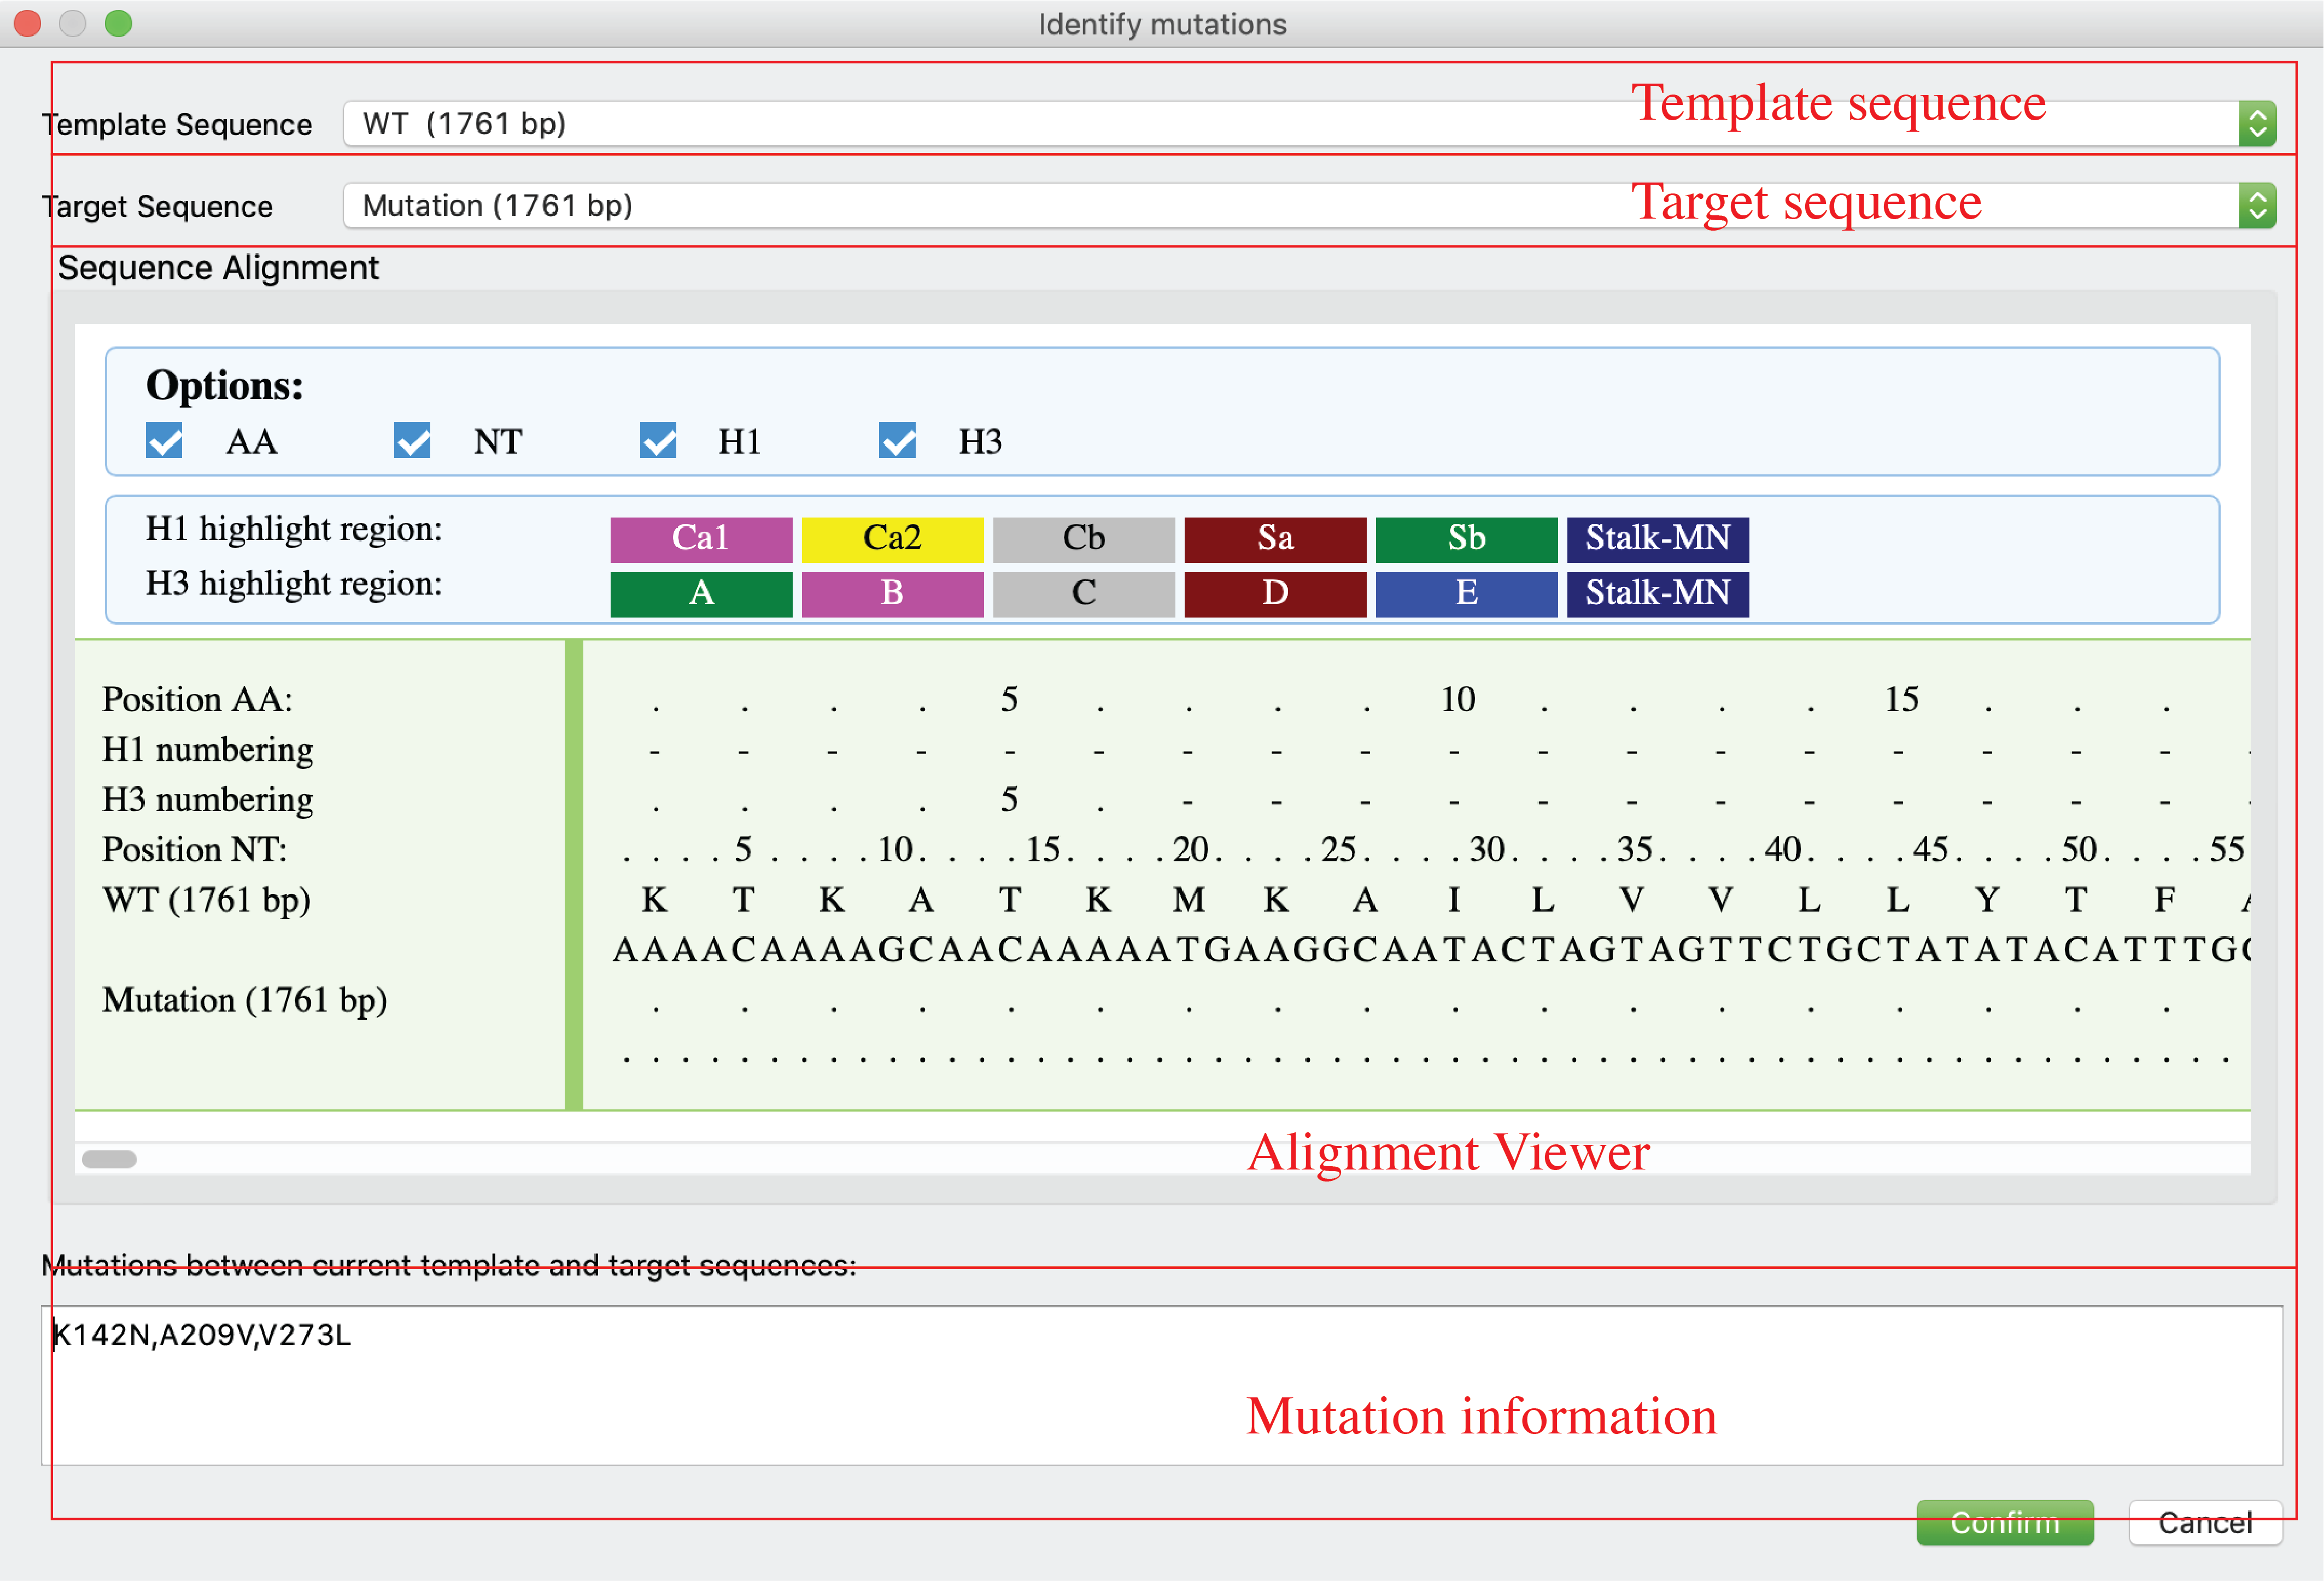

### Multiple sequence alignment

Users can align multiple sequences together and check the results in a graphical viewer.

Click *Tools-> Multiple Alignment(HTML)* in menu or just click  in *Tool bar* for an alignment viewer in a popup window or click Alignment(HTML) tab for an integrated and alignment viewer. There are two display modes: original sequence mode and template mode. In template mode, users can choose any sequence (including consensus sequence) as template to only highlight sequence difference.



### Generate phylogenetic tree (ML tree)

Users can generate phylogenetic tree (Maximum Likelihood tree) for selected sequences. Nucleotide and Amino Acid trees are available.

For Nucleotide tree:

Click *Tools-> Generate Maximum Likelihood Tree (nucleotide)* in menu or just click in *Tool bar*.

For Amino acid tree:

Click *Tools-> Generate Maximum Likelihood Tree (Amino Acid)* in menu or just click  in *Tool bar*.

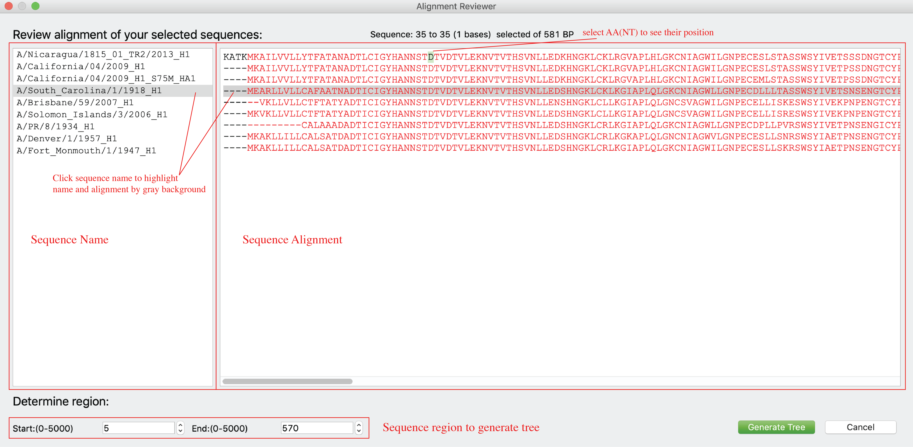

### Mutate sequence

Users can generated new sequences with mutations based on any existing sequence.

Click *Edit Sequence-> Mutation* in menu or just click in *Tool bar*.

As shown below, users can generate mutations on a template sequence using either original position (count from first amino acid, panel A) or H1/H3 numbering (H1 numbering for group1 virus and H3 numbering for group2 virus, panel B). H1/H3 numbering function is only enabled for HA sequences of FLU A.

Users are allowed to input multiple mutations at the same time, and are allowed to decide from two options: 1) generate one sequence with all mutations; 2) generate multiple sequences, each of them with a single mutation.

After the mutated sequence was generated, users can visualize the 3D structure (only enabled for HA now) of generated HA protein (panel C).

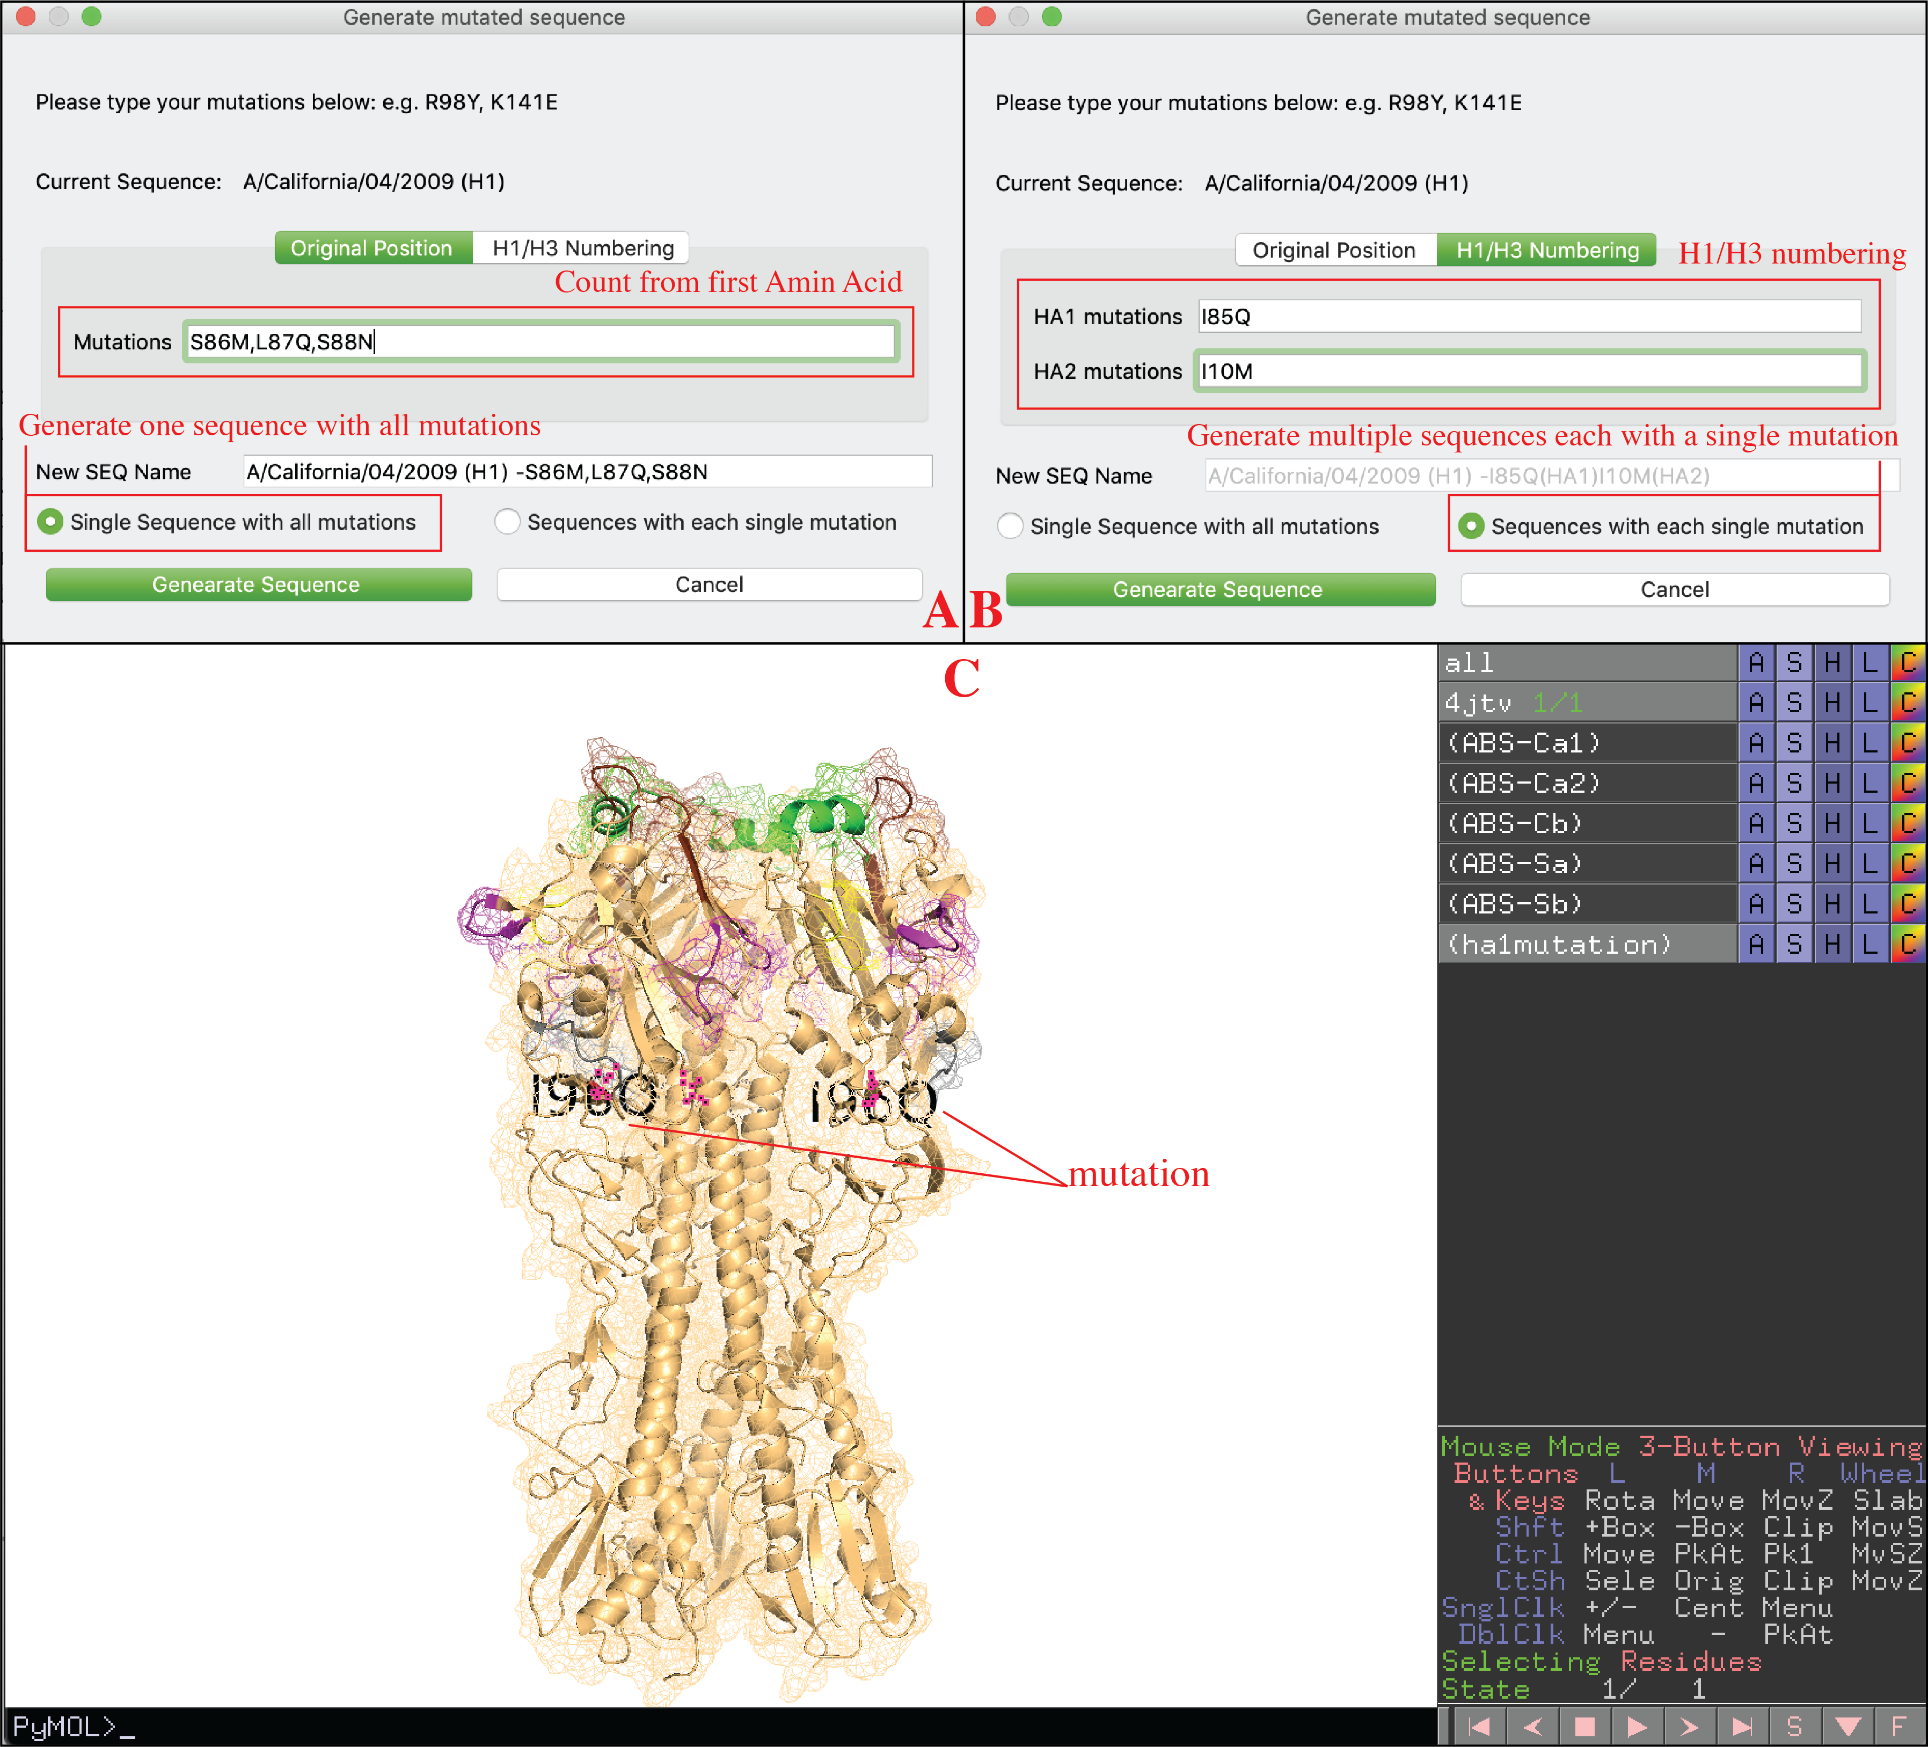

### Compare sequences and generate screening mutations

Users can compare sequences and generate consensus sequences (Base biased) or new sequences with screening mutations (Cocktail).

Click *Edit Sequence-> Editing* in menu or just click in *Tool bar*.

*Cocktail mode* **(A):**

Compare base sequence to another sequence, identify all mutations between two sequences on donor region of donor sequence (user can setup donor region on this interface), then generate new sequences with those mutations using base sequence as template. Users can choose to only generate sequences with single mutations or all combinations of mutations.

*Base biased mode* **(B)**:

Generate consensus sequences of base sequence and selected sequences. For each donor sequence, only their donor region will be considered (full sequence will be considered when donor region is none).

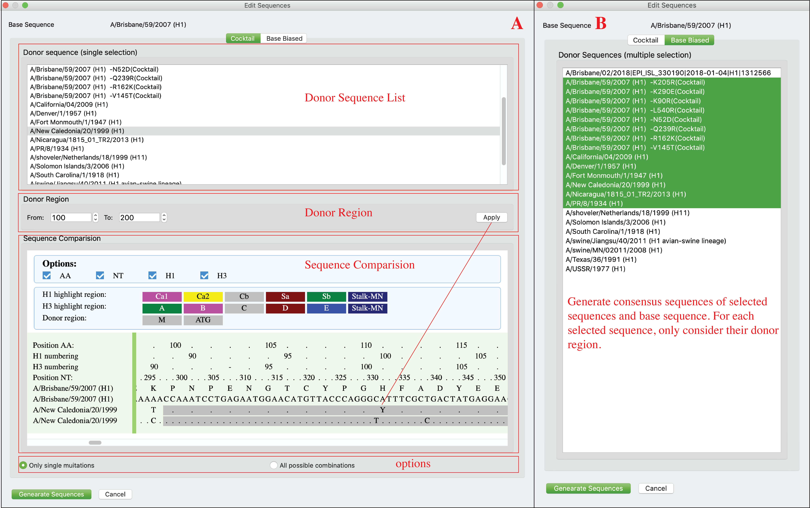

### Epitope transplant across different subtypes

Users can transplant epitopes/regions from sequences of different subtypes.

Regions being removed from base sequence and that being inserted from donor sequence are not necessary to have same length.

Users can add multiple replacements on one sequence (click ‘Add’). Those replacements could be from different sequences. Users can review the replacement design in the bottom window. Users can double click replacement to delete it. Users also can click ‘Clear’ button to rest current design.

Click *Edit Sequence-> Fusion* in menu or just click 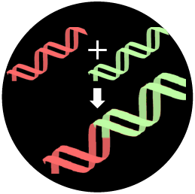 in *Tool bar*. This window has two layouts: high resolution layout and low resolution layout. Liberator will automatically choose the best fit based on current display resolution. Users also can click *Edit Sequence-> Fusion (high resolution)* or *Edit Sequence-> Fusion (low resolution)* to determine the layouts they prefer (As shown below).

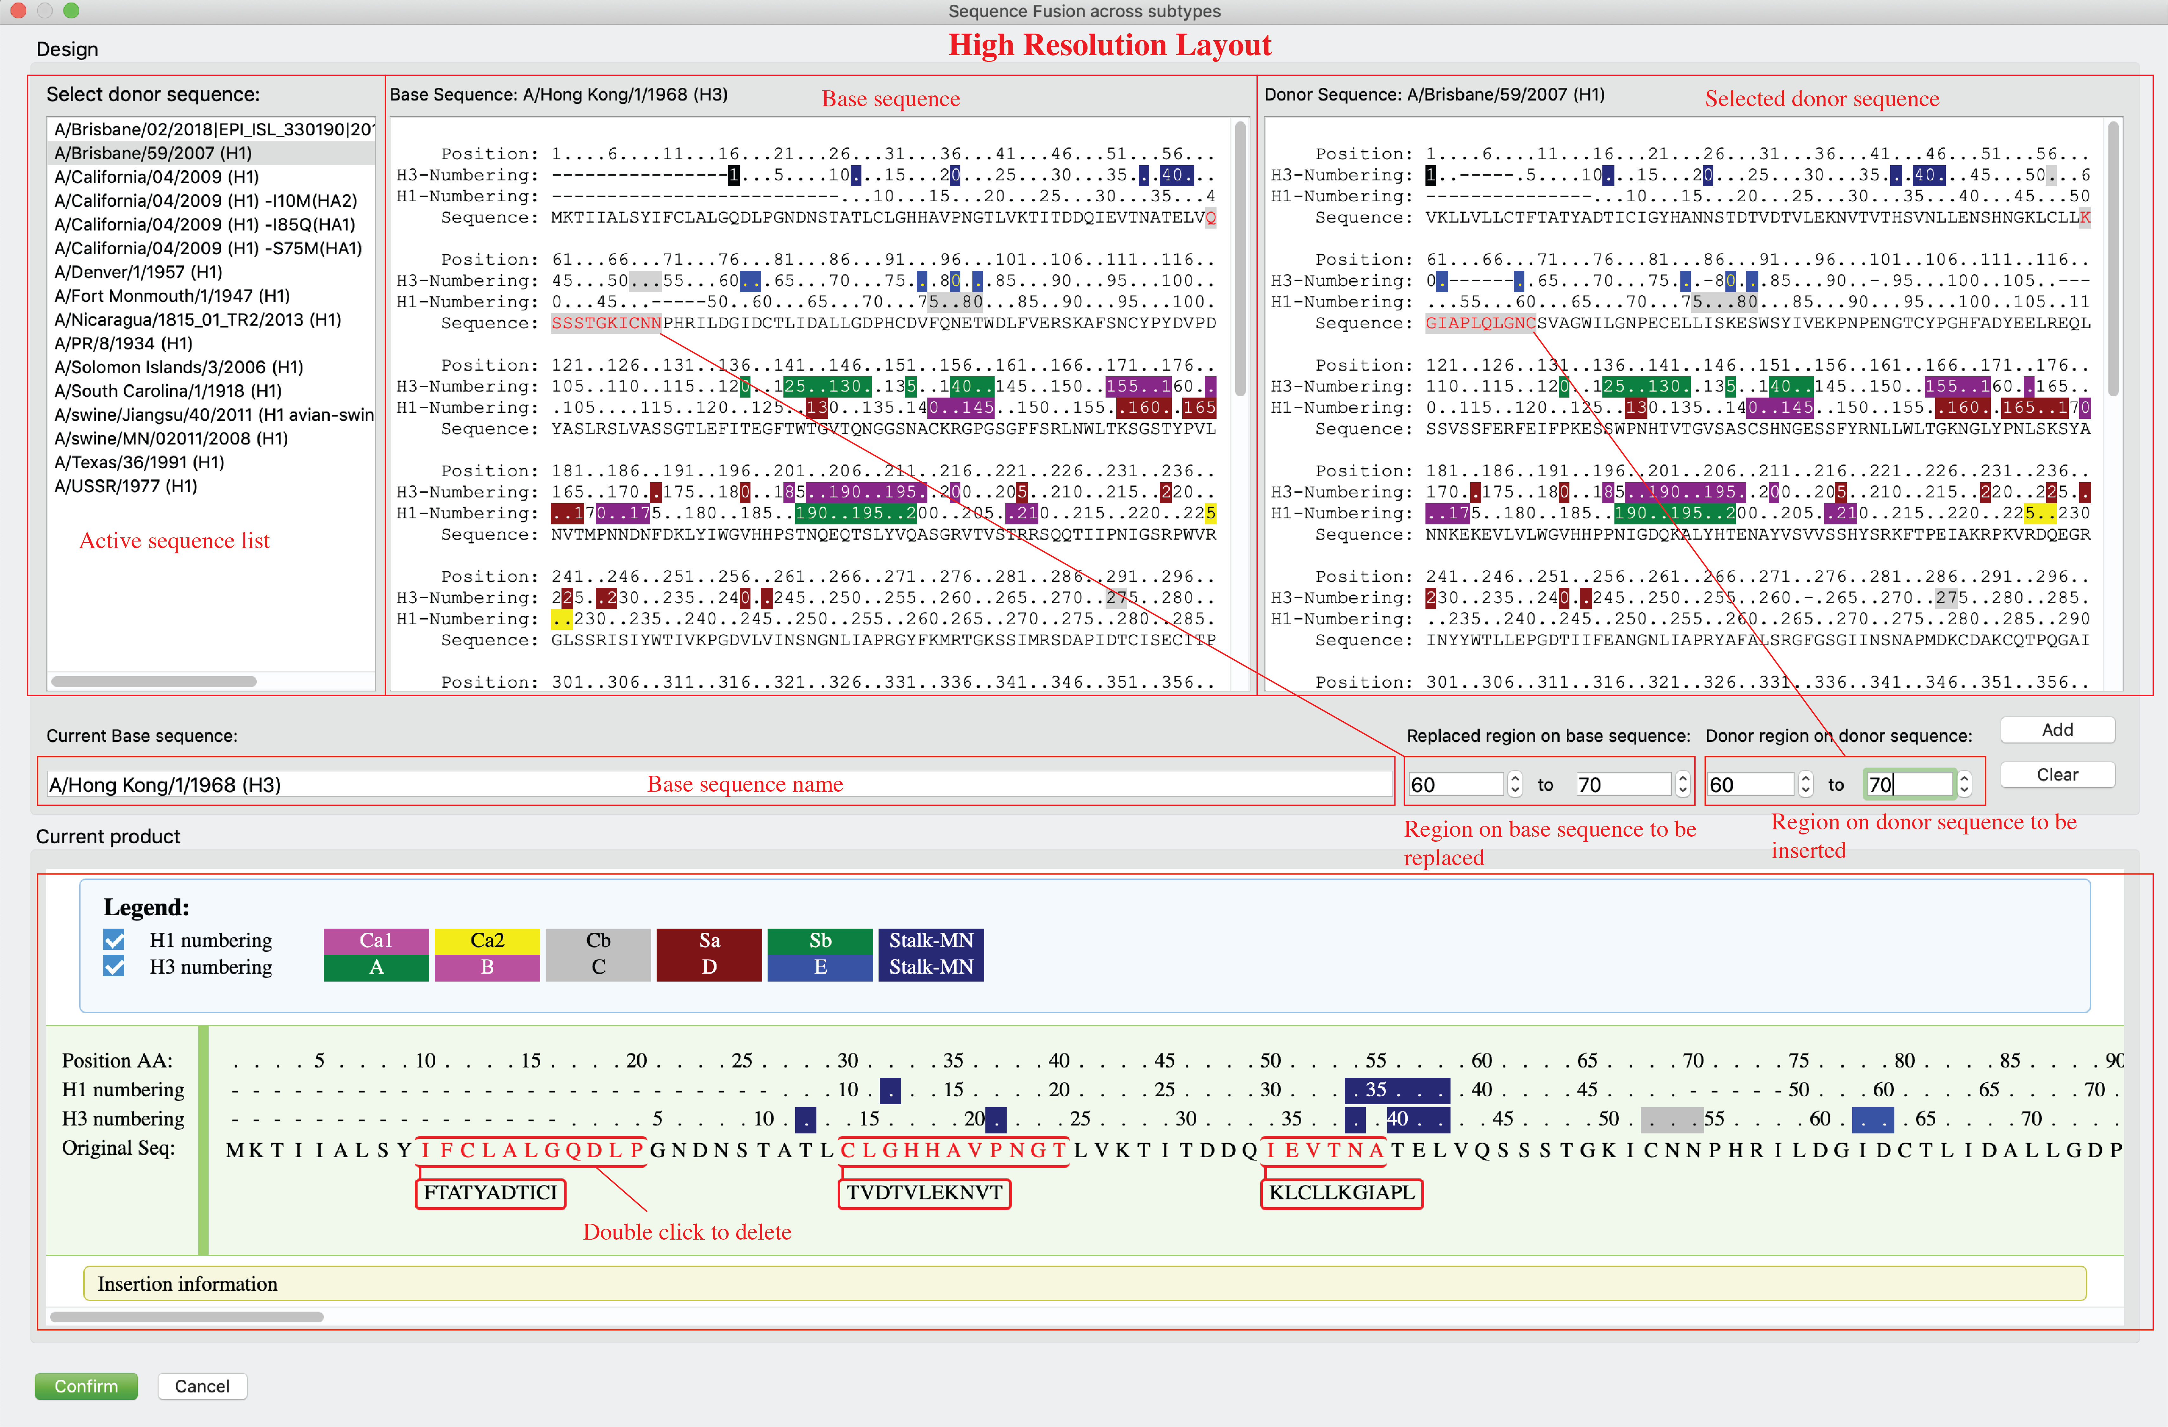

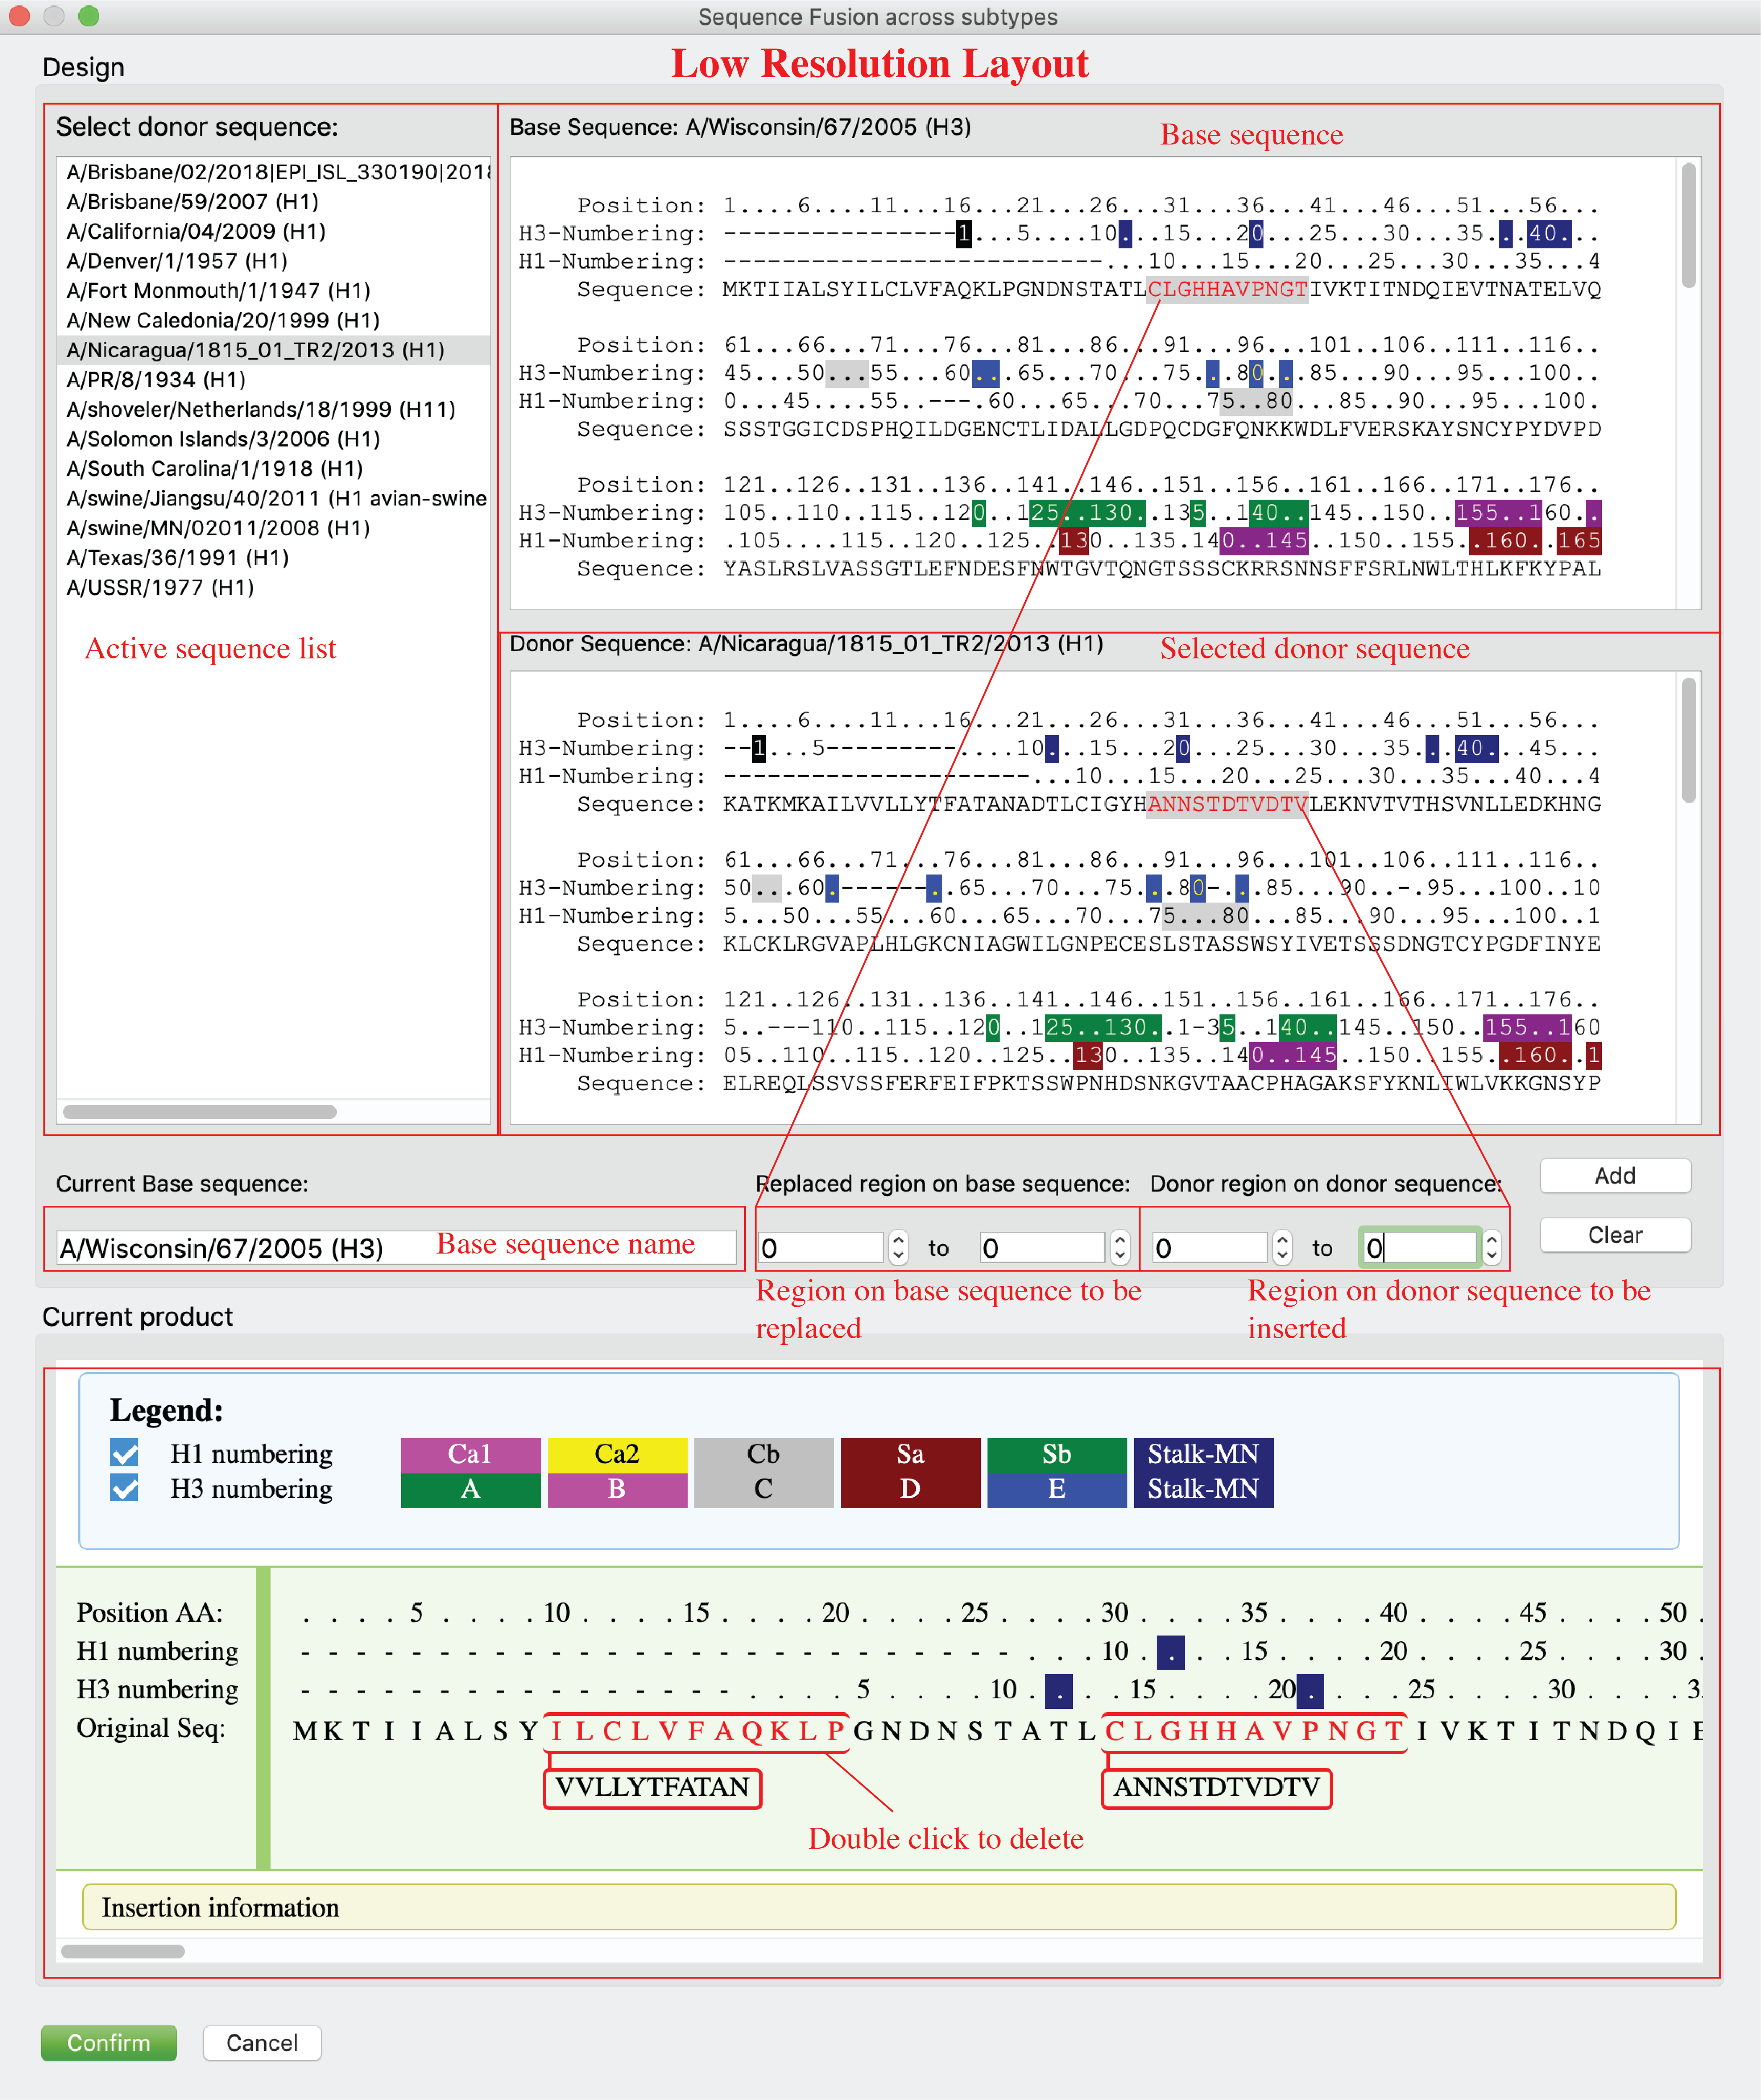

### 3D visualization via PyMOL

Users can see 3D structure of selected sequence via PyMOL (only for HA).

Click *Visualization-> PyMOL* in menu or just click 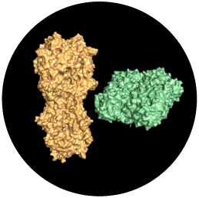 button.

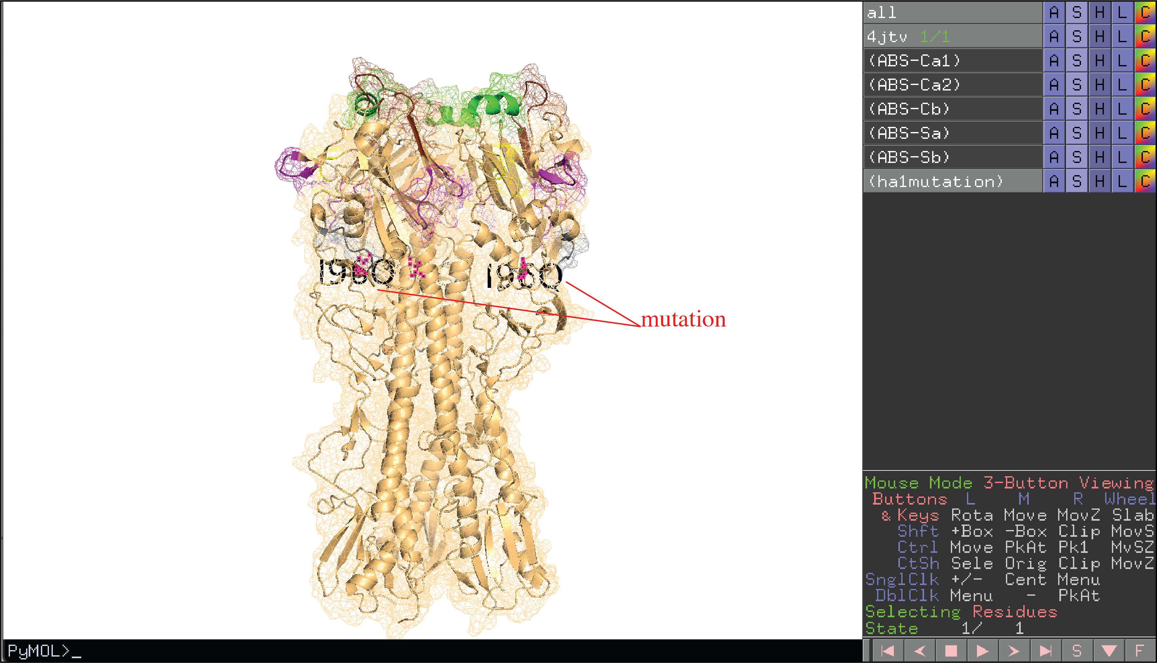

### Generate Gibson Clone fragments

Users can generate Gibson Clone Fragments.

Click *GibsonClone*-> *GibsonClone* in *menu* or just click  button on Main tab.

Note: *GibsonClone* only works for sequences within same subtype!

Users can select sequences, determine fragment DB, output path, and joint region plan (panel A), after click “Generate Fragments” button, a dialog will pop up for users to review and confirm (panel B). On panel B, users can review the generated Fragments (both amino acid sequences and nucleotide sequences), joint regions that shared by neighbor fragments are highlighted. Joint region that connect fragment 1 and 4 to the vector not displayed for AA sequences but can be found in NT sequences. ‘-’ in AA alignments indicate incomplete sequences or deletions and will be deleted in NT fragments. Users can click “confirm” button to generate fragments after they confirmed current fragments. After a few second, a notice will be popped up with summarized results (panel C).

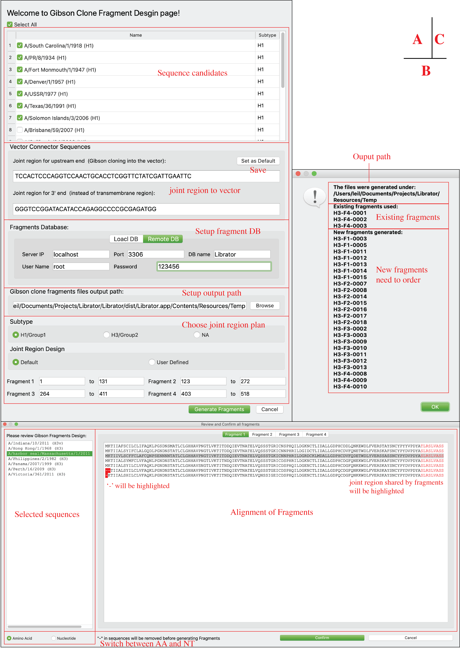

# Contact

For comments and feedbacks please E-mail Lei Li([leil@uchicago.edu](mailto:leil@uchicago.edu)) or Patrick C. Wilson([wilsonp@uchicago.edu](mailto:wilsonp@uchicago.edu))